|  |  |  |
| --- | --- | --- |
| CS 531_01 | | November 2  2015 |
| Assignment 2 |

**Submitted By:**

Akshay Pandey

Dheeraj Mukati

Yukti Sarwadia

[Bikers Club Link](http://cs99.bradley.edu/~ysarwadia/site/) - Project Link

1. **INDEX.html:**
2. Animated Slide show created using <span> followed by C showing Sign Up function...

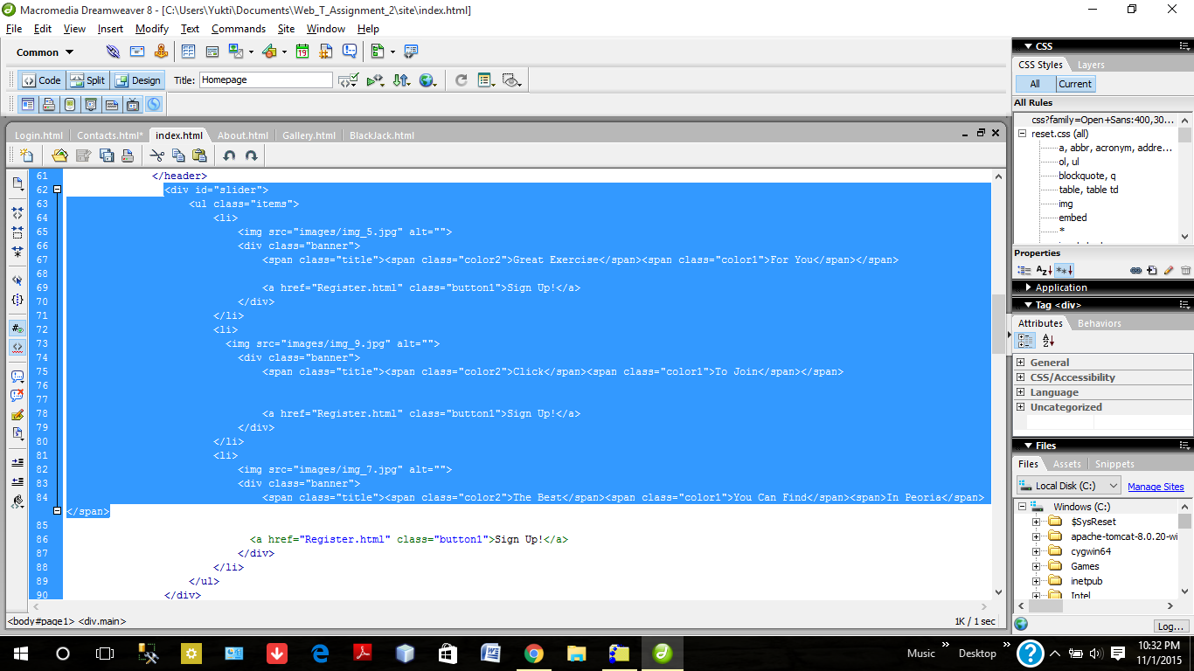

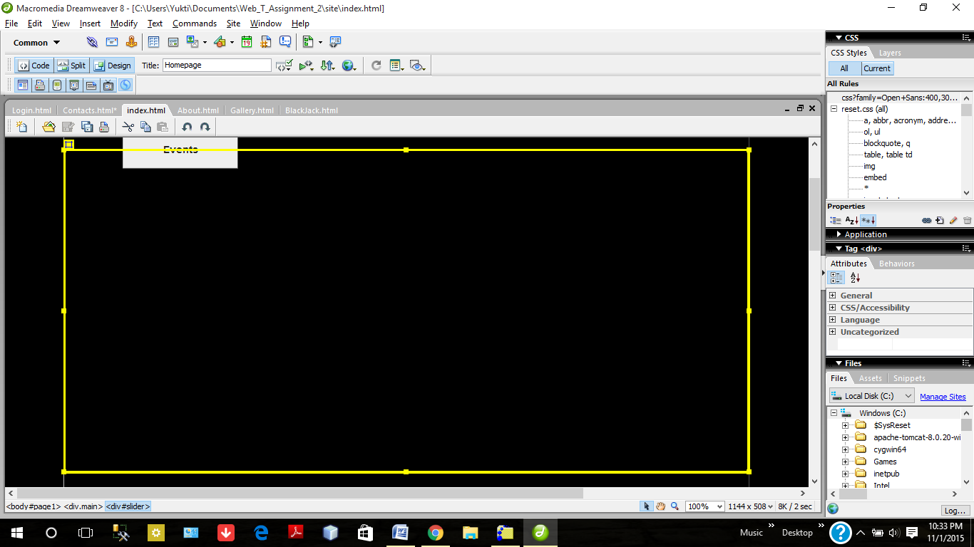

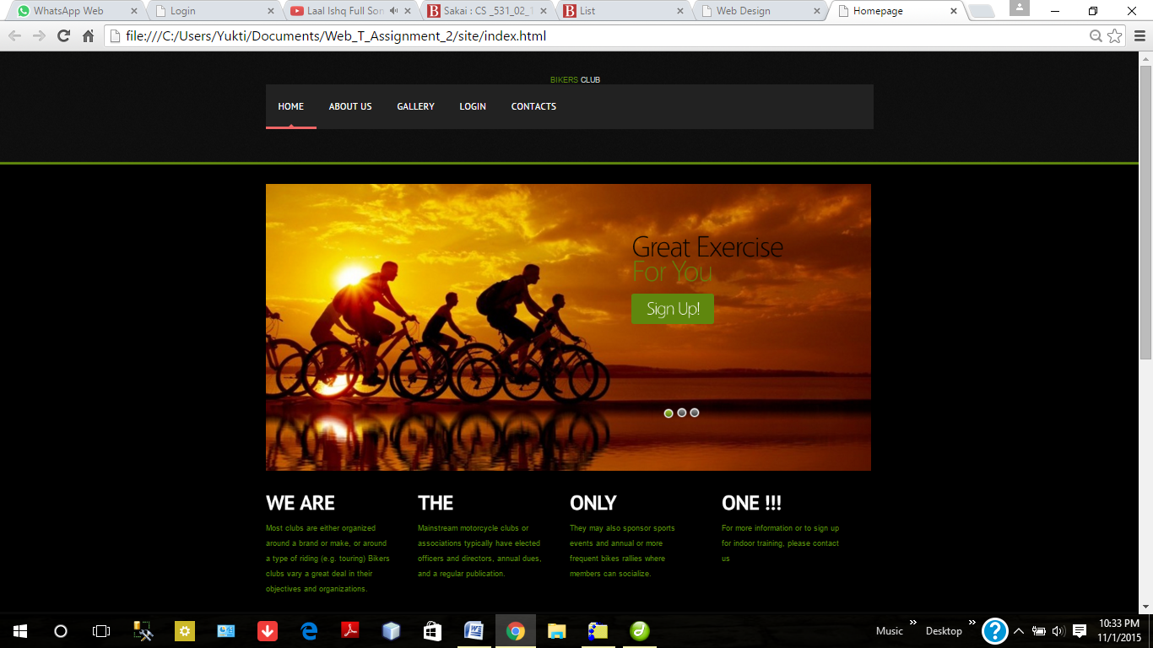

CSS used for SIgnUp Option

Slideshow for INDEX PAGE

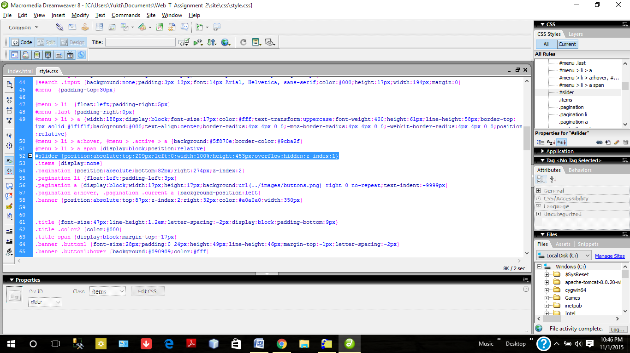

1. **Pull Down DHTML menu:**

We have provided the pull down menu for About Us section using JavaScript which shows two options Membership and Events using unordered list tag and <nav> tag.

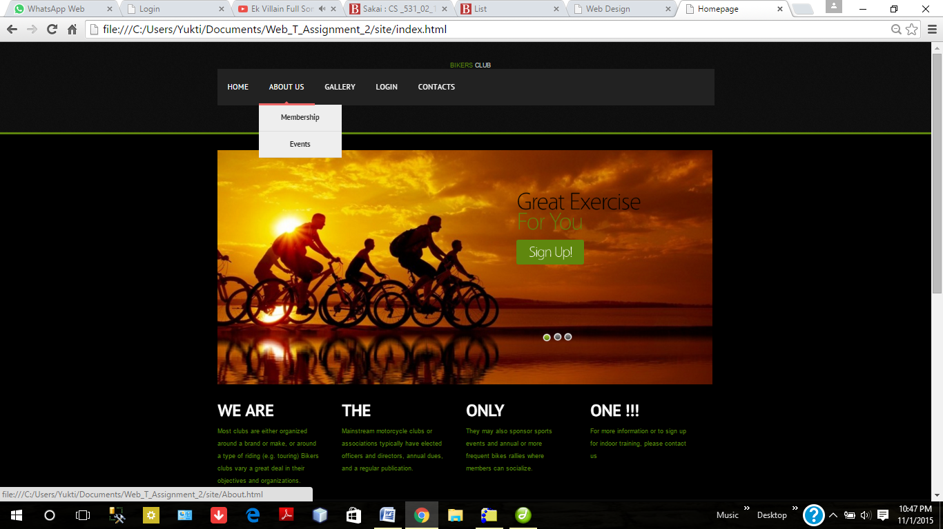

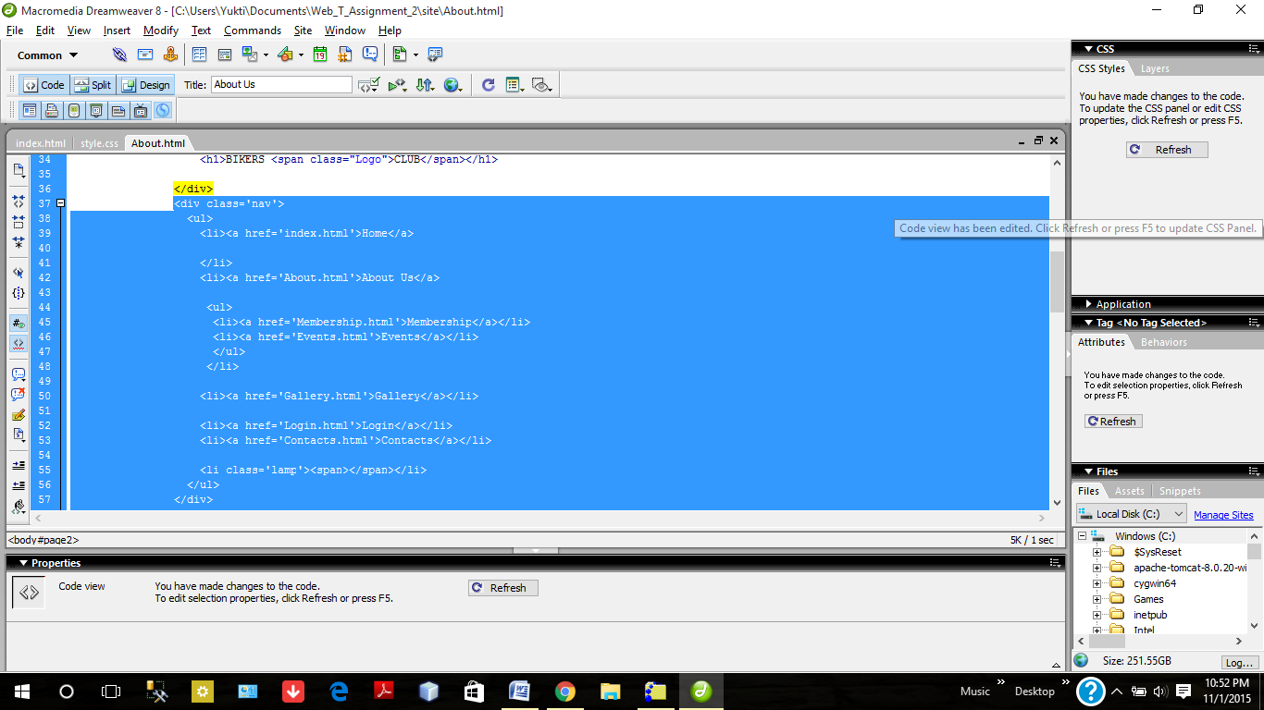

1. **Date Object implemented using JavaScript.**

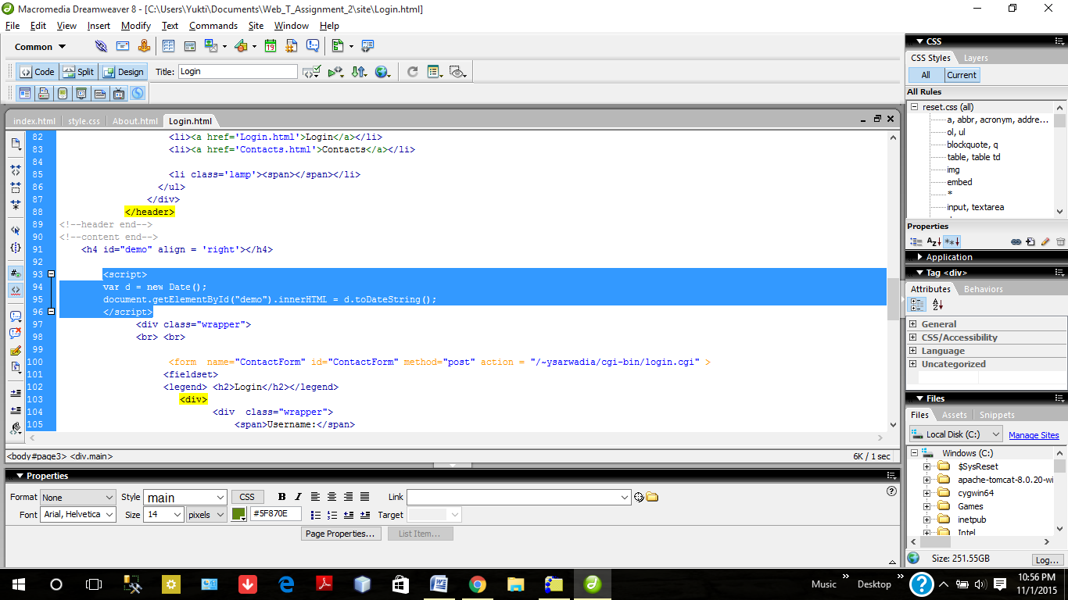

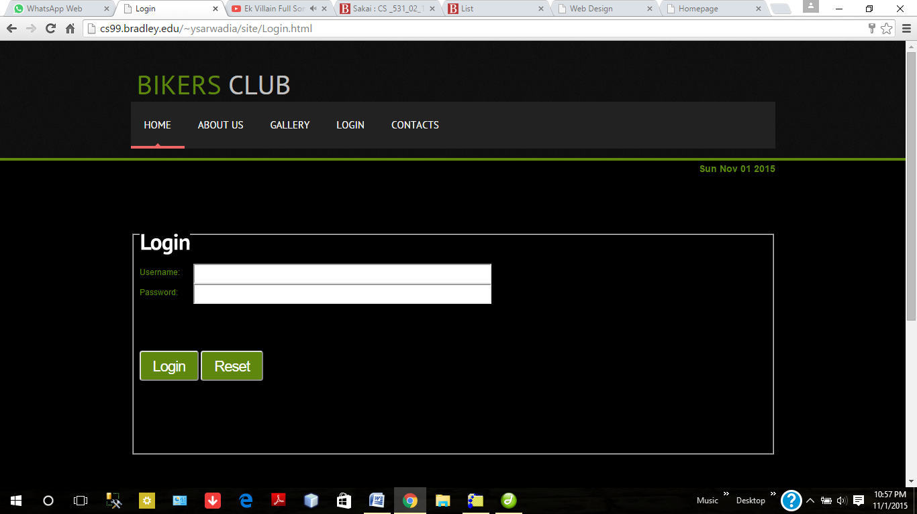

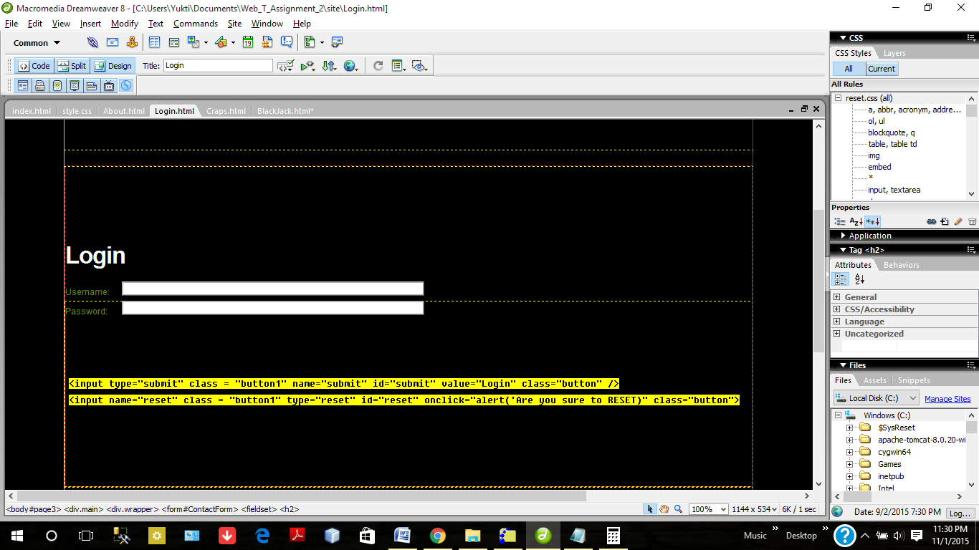

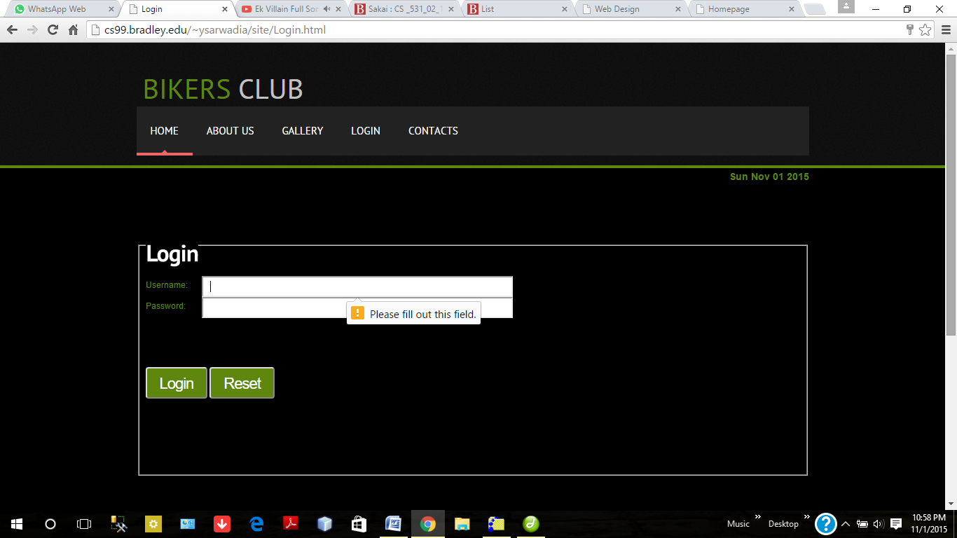

HTML5 inbuilt validation.

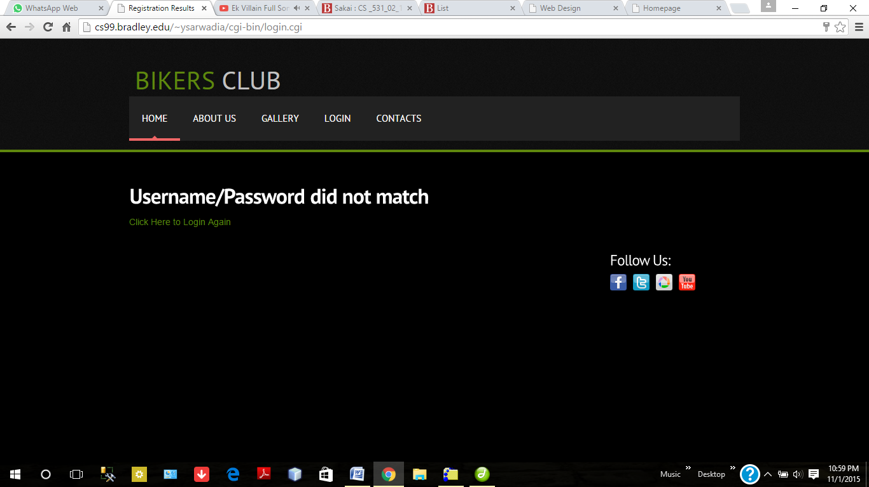

Validation using cgi when username and password don't match.

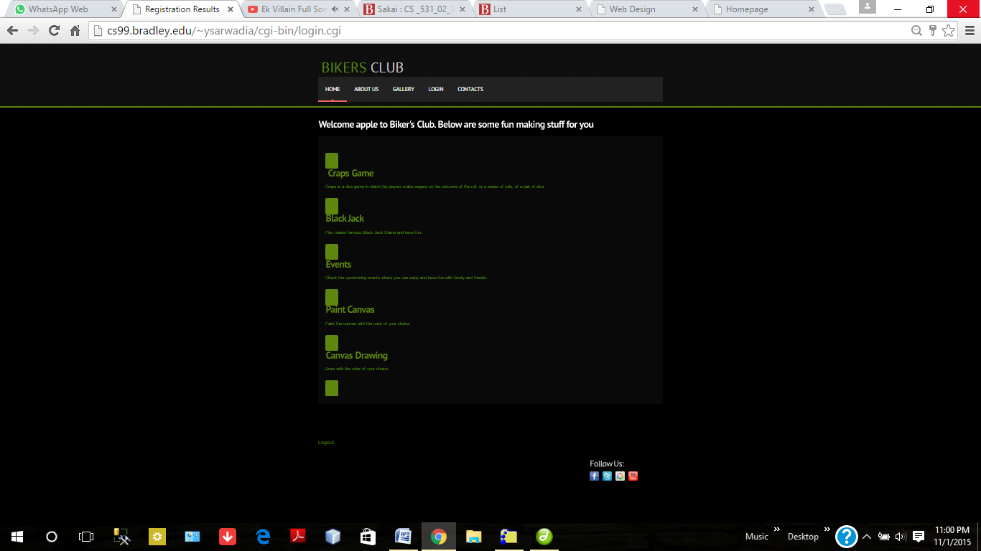

When Login is successful.

1. **Craps Game**

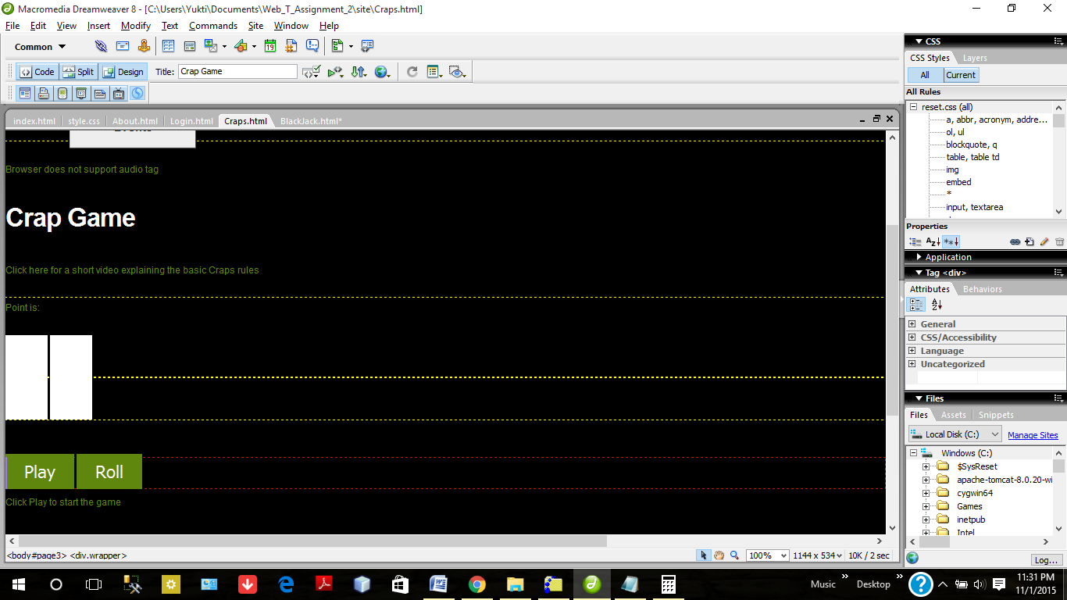

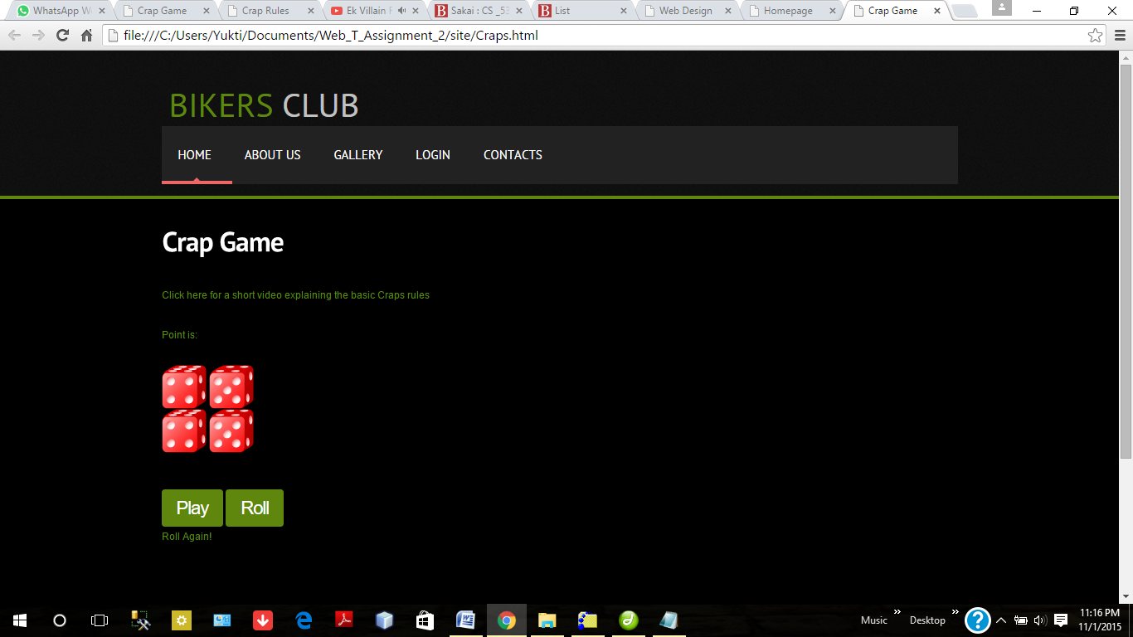

Crap Game implementation. Help video linked to crap game

Two Button Implementation.

Embedded with sound file

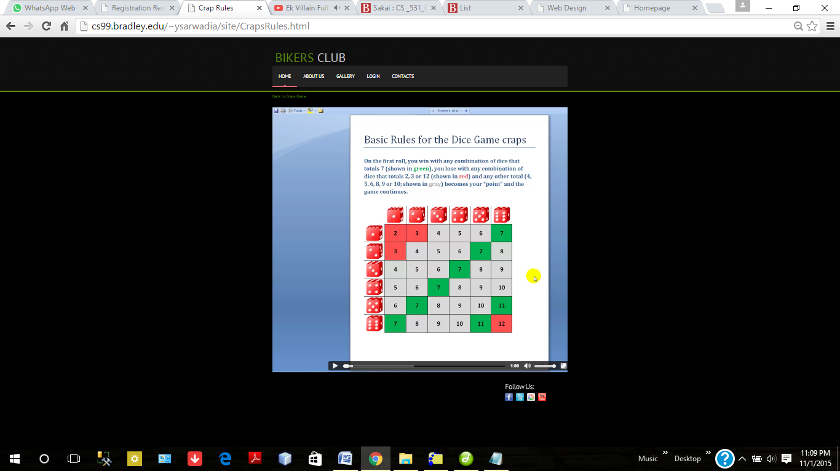

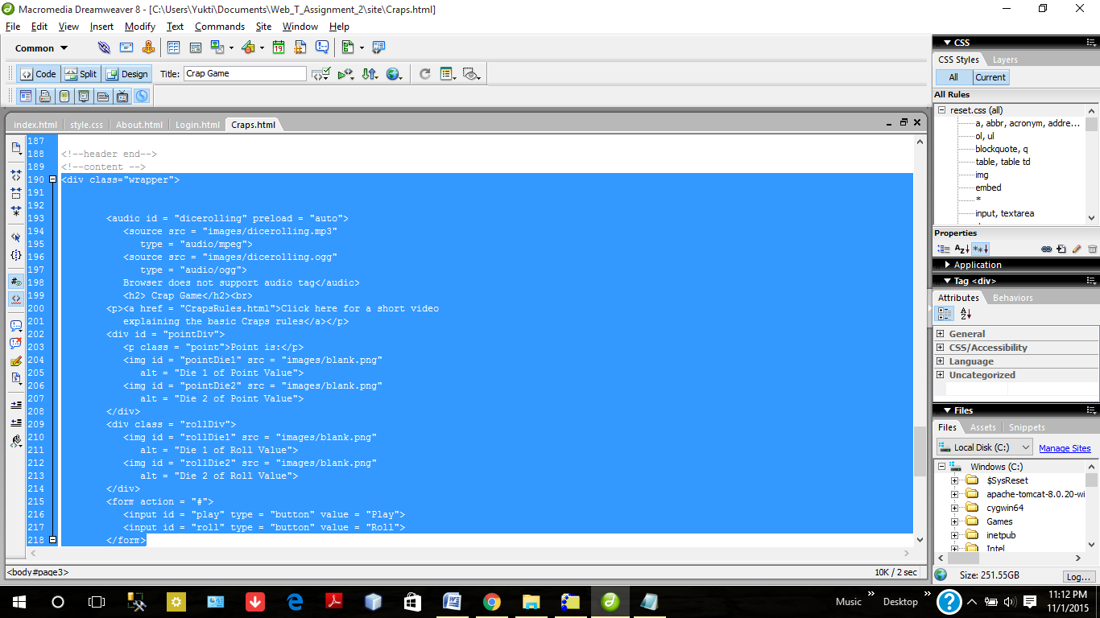

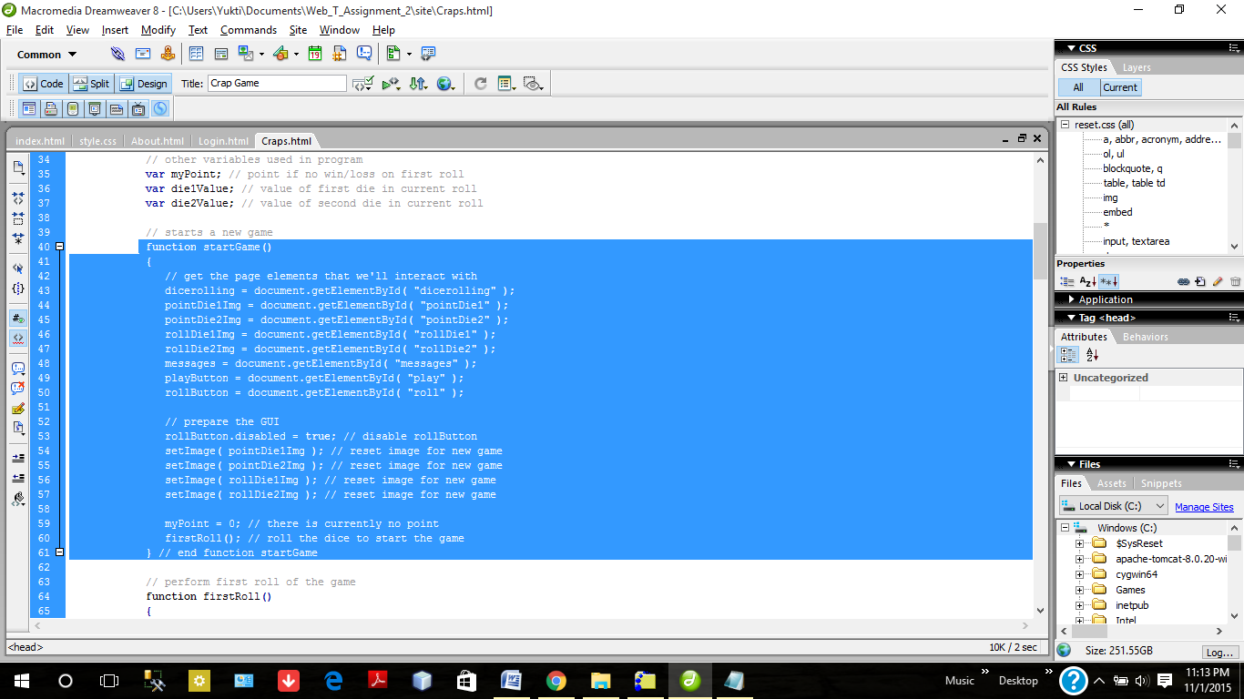

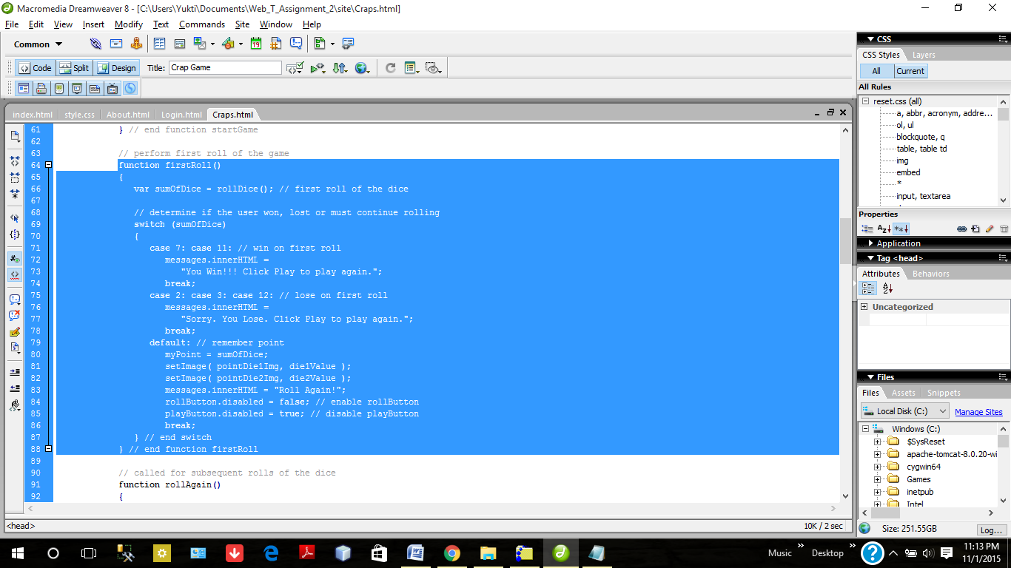

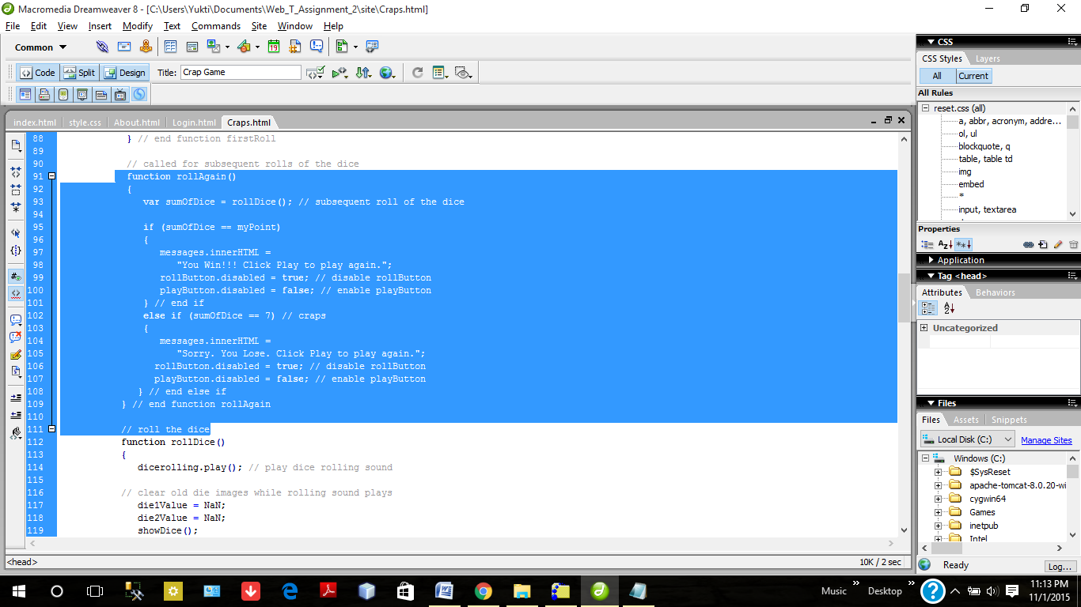

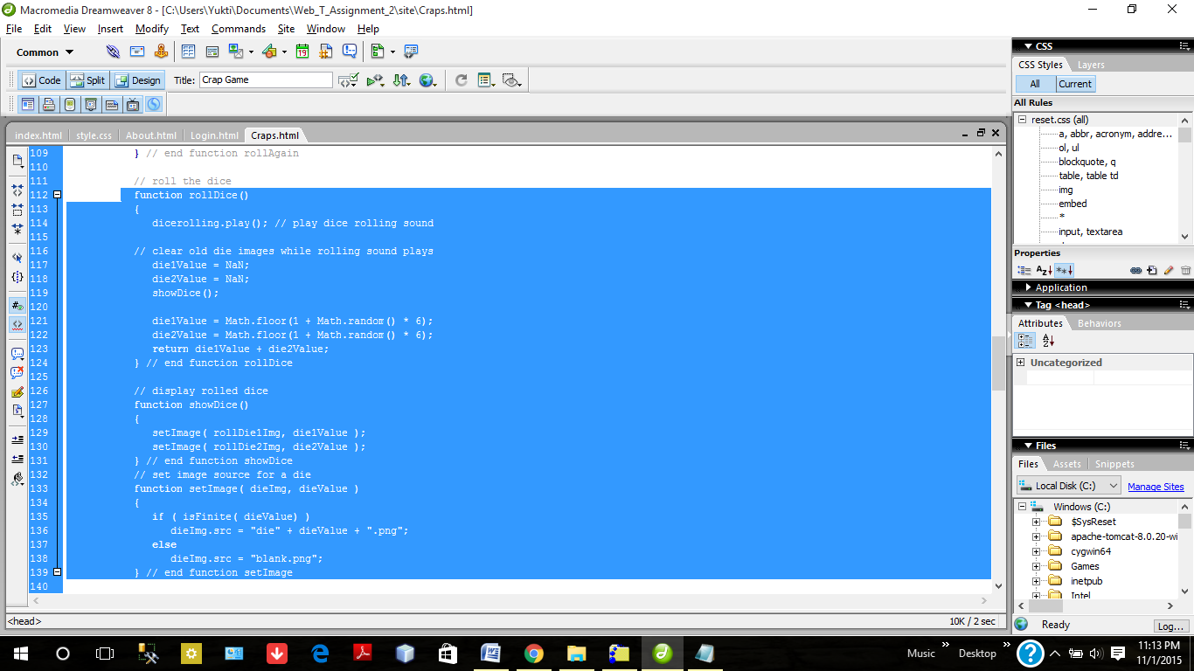

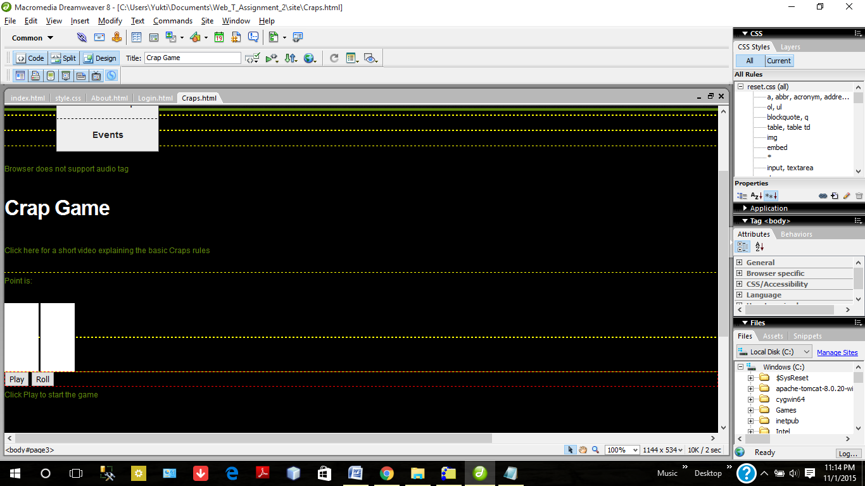

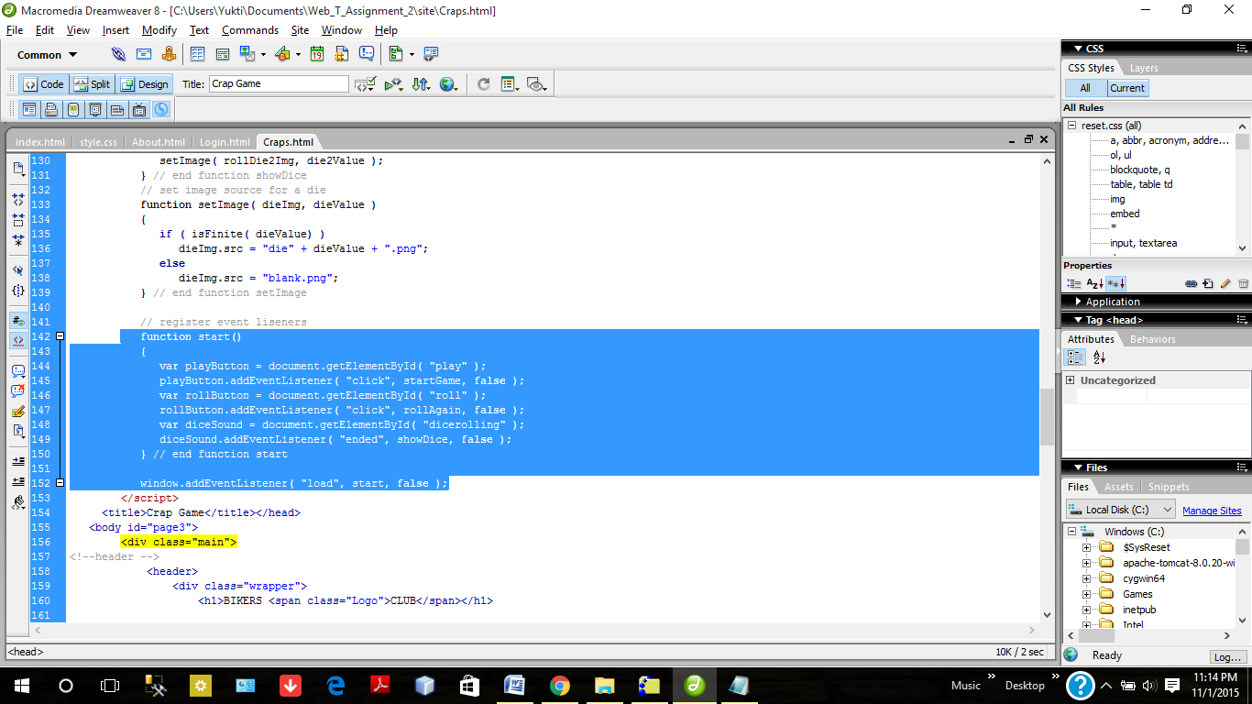

1. Black Jack Implementation

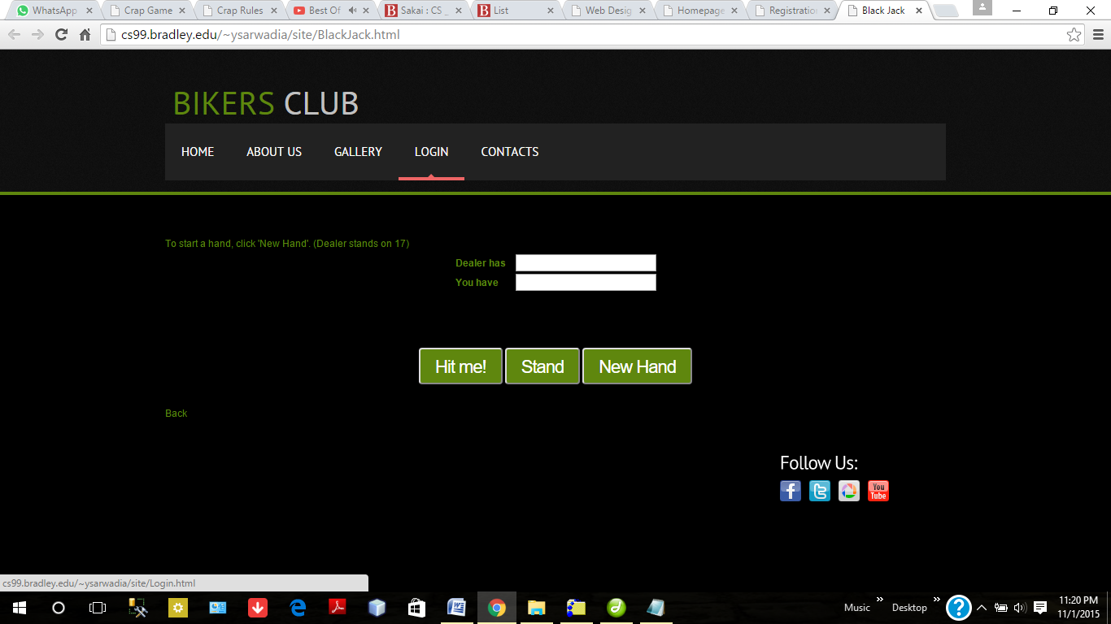

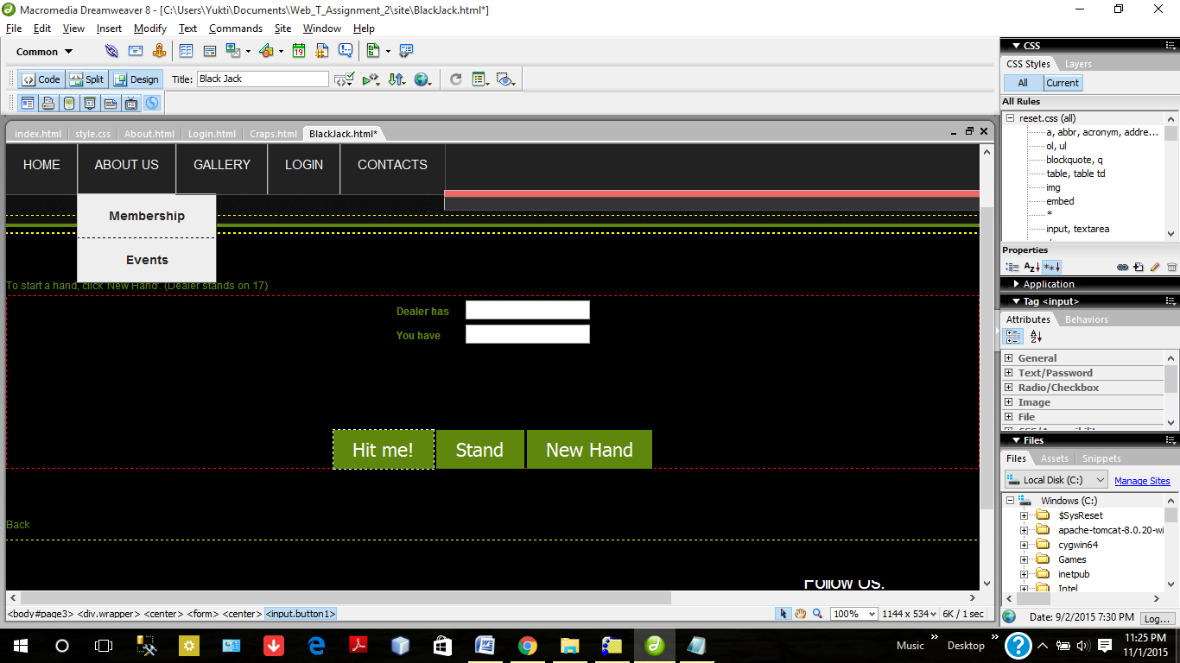

User has to click on New hand button to start the game. The code will set the random value less than 21 on first time to both Dealer and User.

If user finds that he is very far from 21 than he can ask for more cards by clicking on the Hit Me button. Then code will add some random no to the User filed.

It will show the count of the cards directly.

If User find himself at a level where he doesn't want to play anymore then he can click on Stand button. If User will have 21 then User has won the game. If Dealer has some value and User has some value less than 21 then whoever has the closest value to 21 will win.

If User will be having value more then 21, then he lost the game.

Clicked first time on New Stand. Some random value will come to both the Dealer and the User.

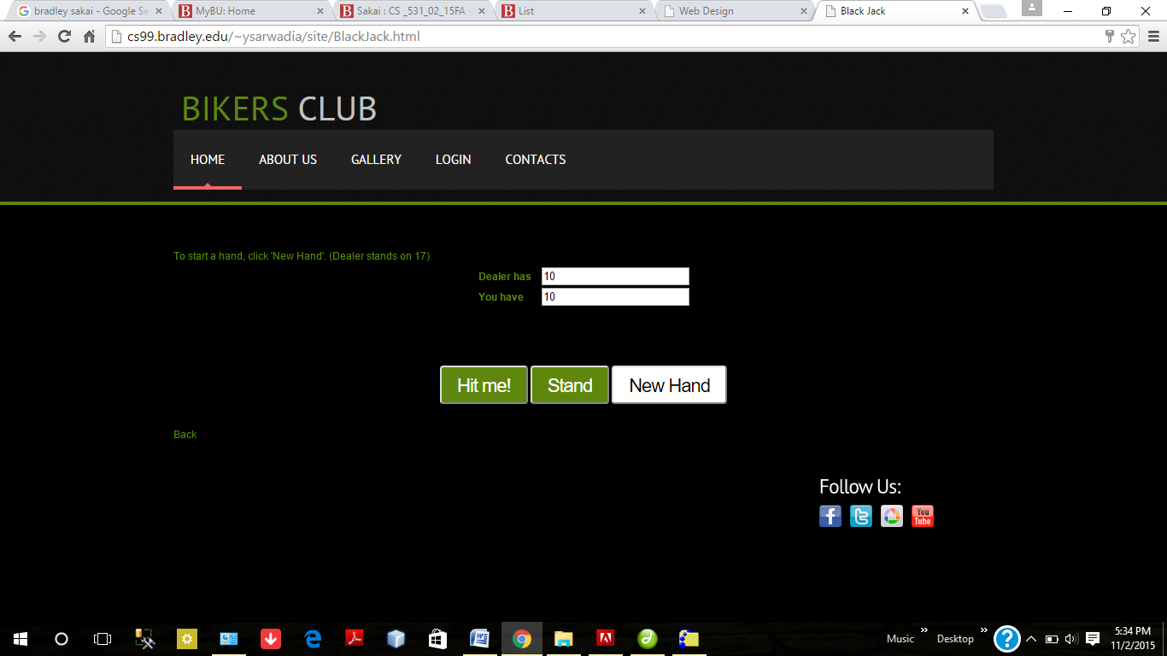

Now the User value is 10 which is very far from 21, he can ask for more cards. He will click on the Hit me Button now.

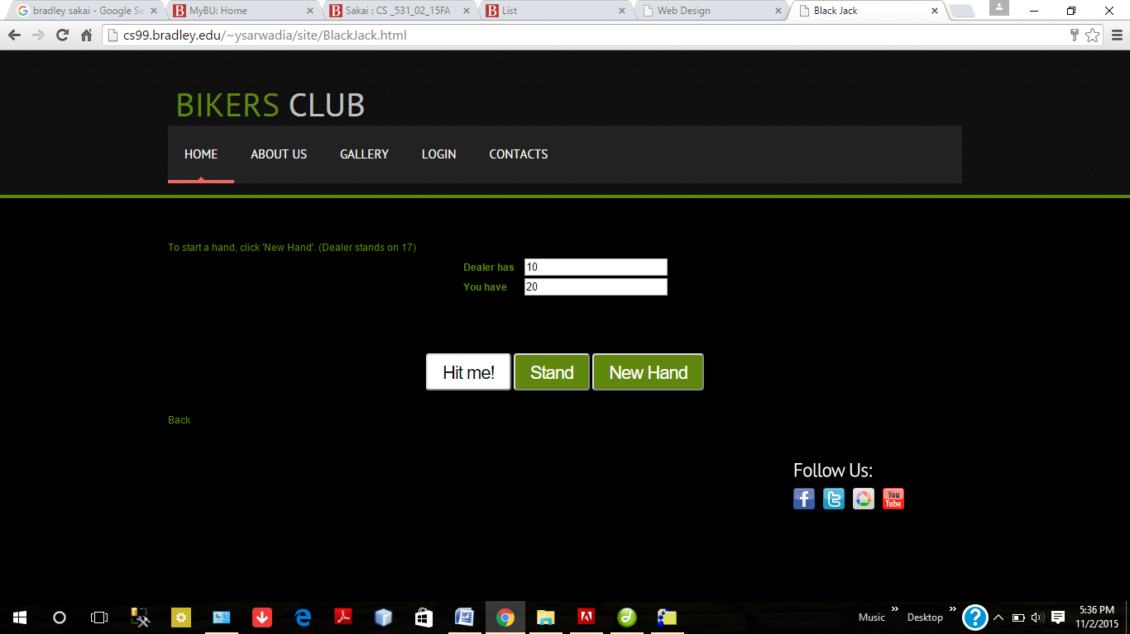

By clicking on the Hit me Button User got 20. That means he is very close to 21. He will not play anymore and will ask for to show the cards.

Now he should click on the Stand button to see the no of Dealer.

In this case, Dealer will win only when he get 21 because User has already got 20 which is the closest to 21.

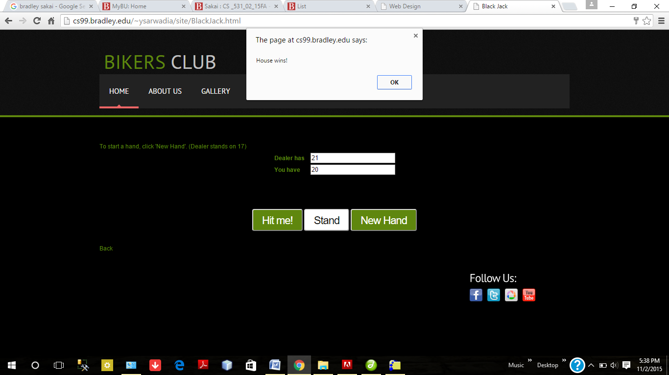

By clicking on the Stand button, Dealer has the sum of cards 21 which means he got the Black Jack. House won , User lose.

1. **Use of animation and alternate rows colored table using for loop.**

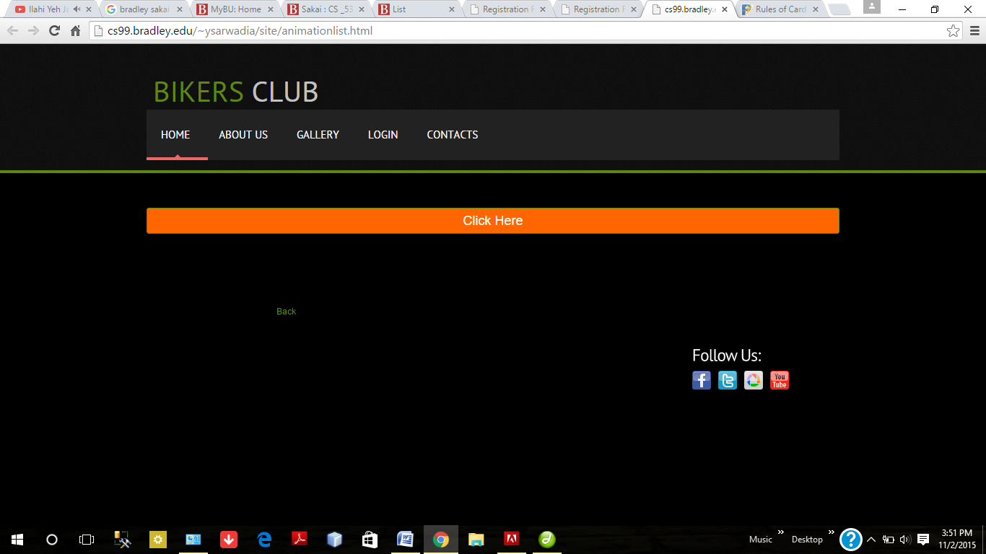

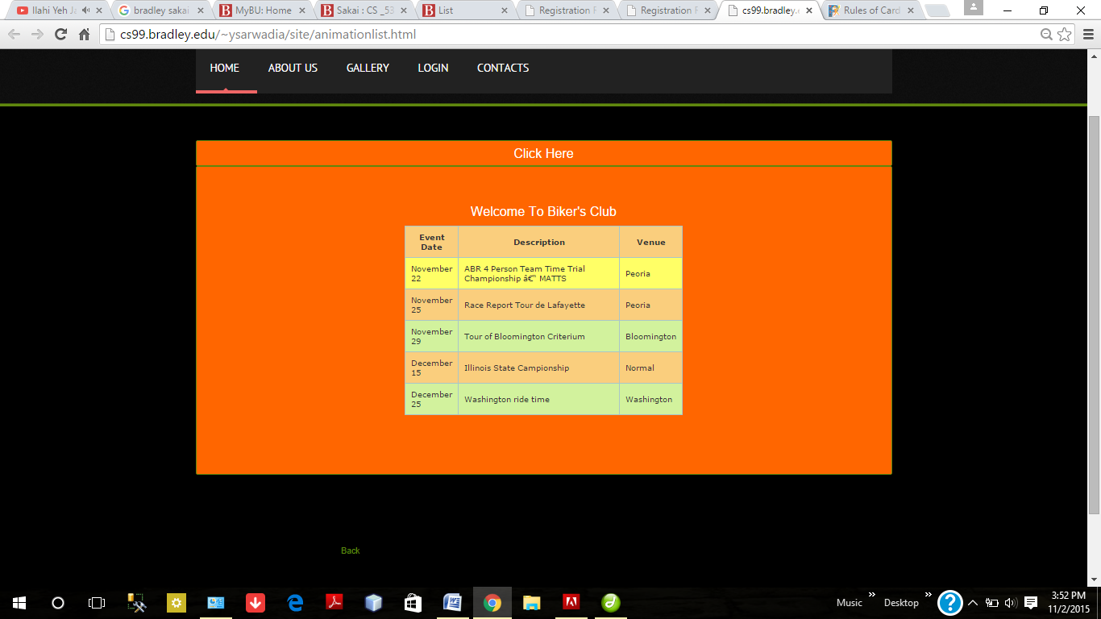

Drop box implemented using JQuery.

Alternate table colors using JavaScript for loop followed by mouse over highlight event

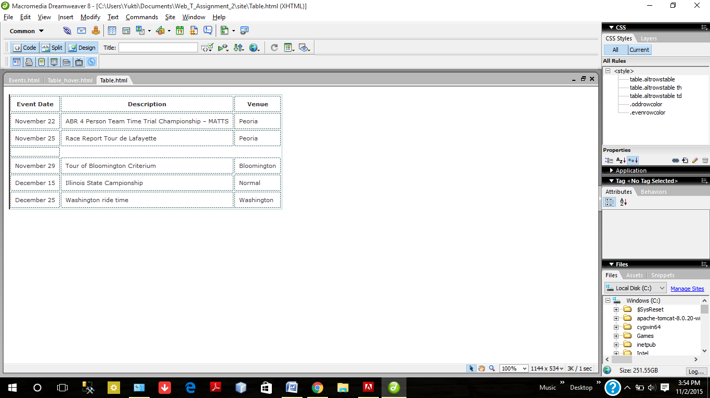

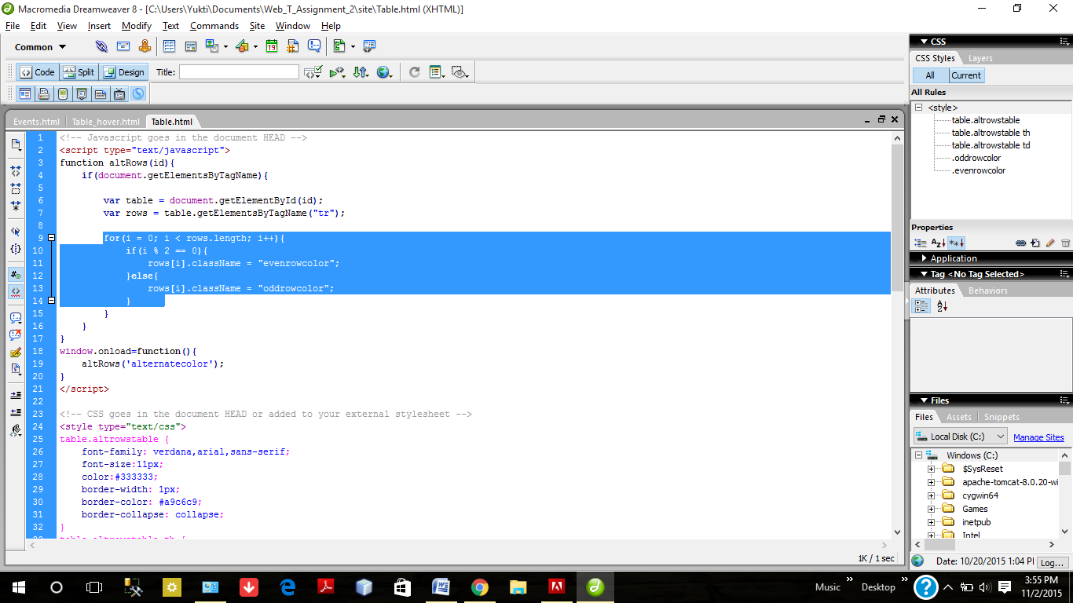

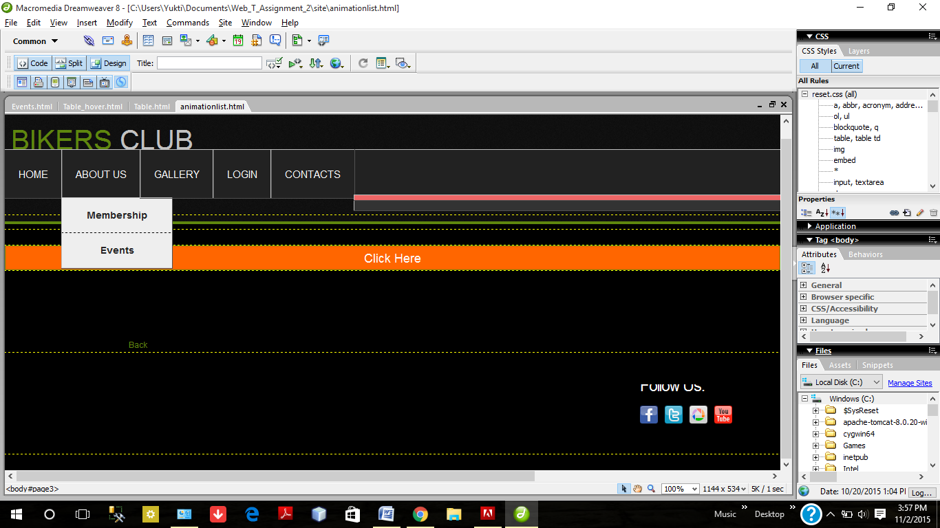

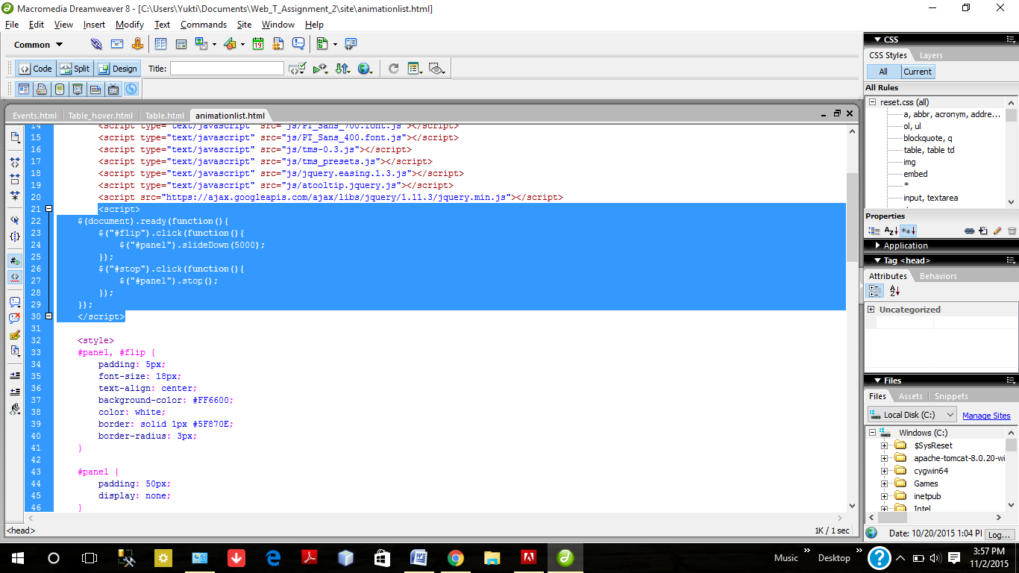

1. **Paint Canvas Game**

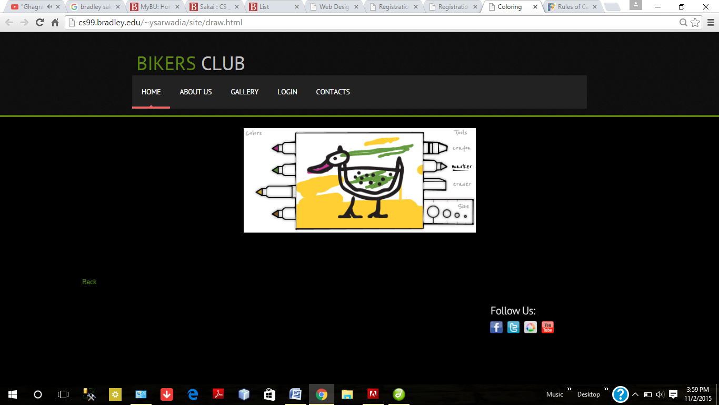

1. Canvas Drawing- To draw with blue press Ctrl and for Red press Shift.

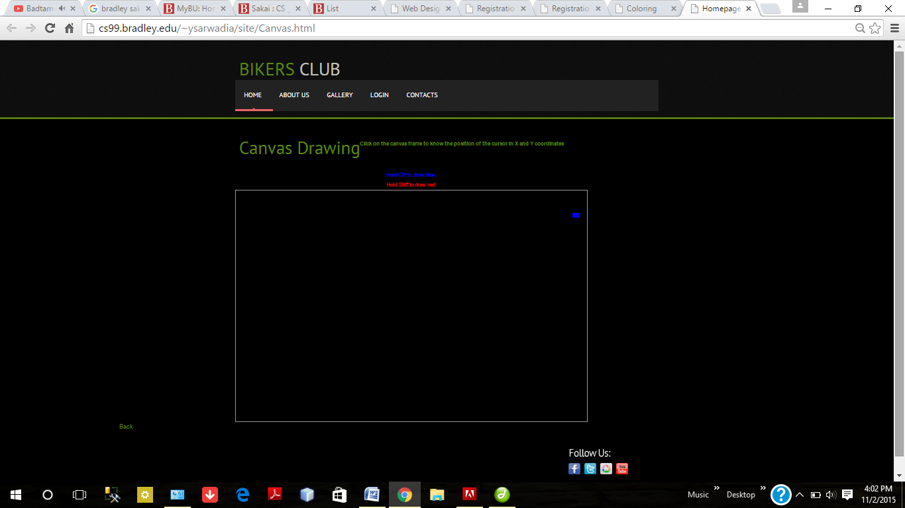

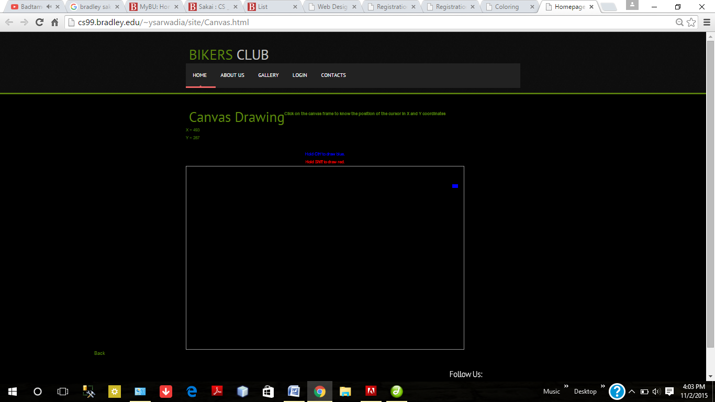

When you will click the border of the canvas; the canvas dimensions will appear.

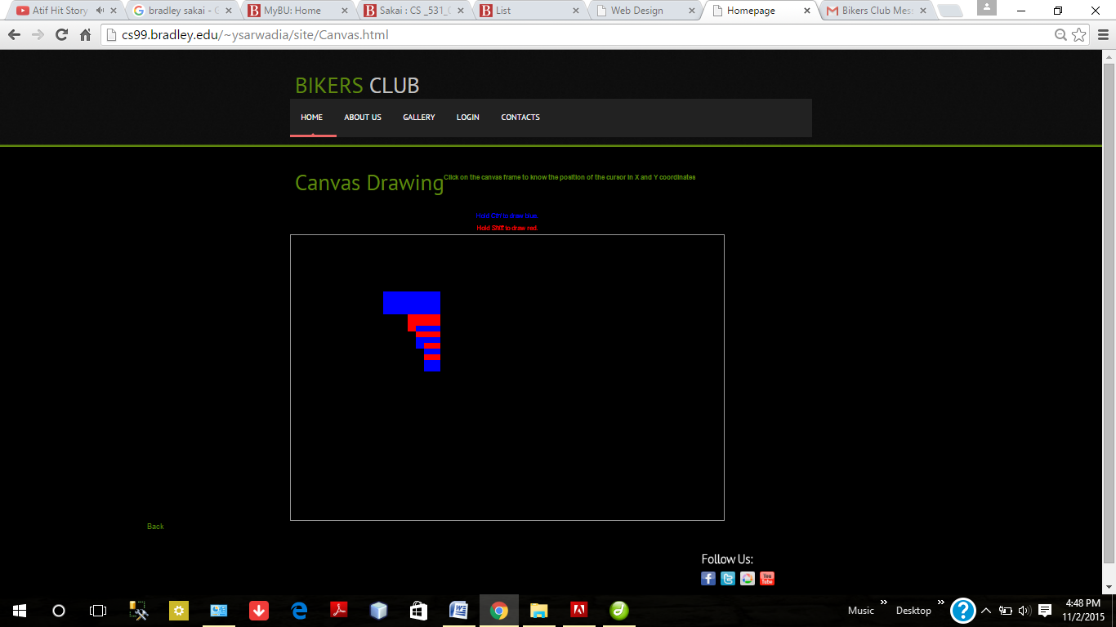

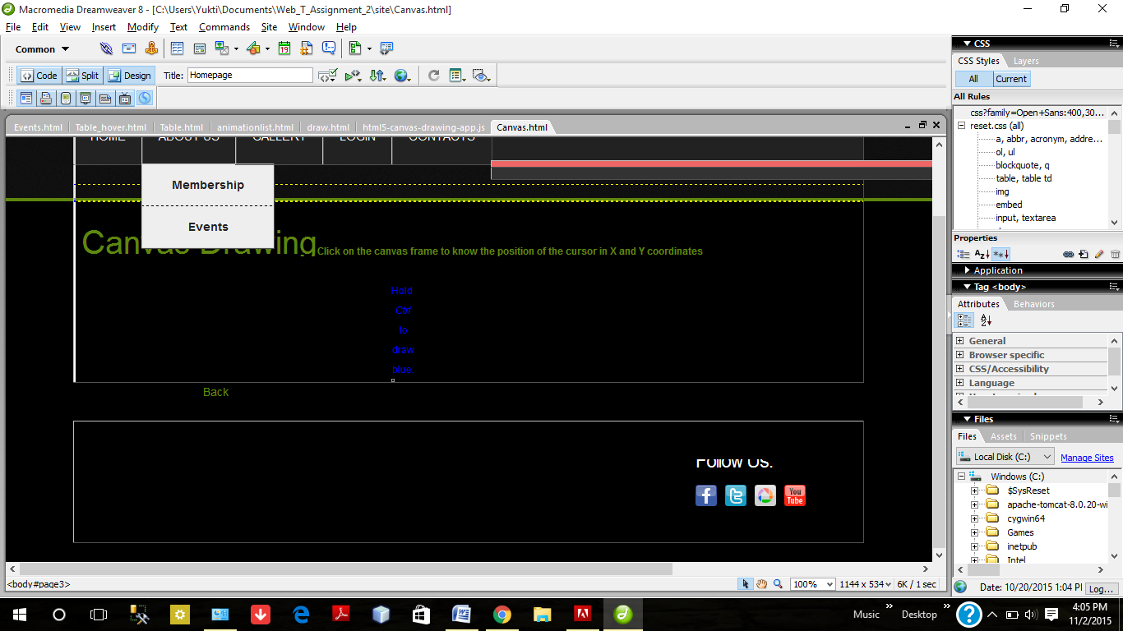

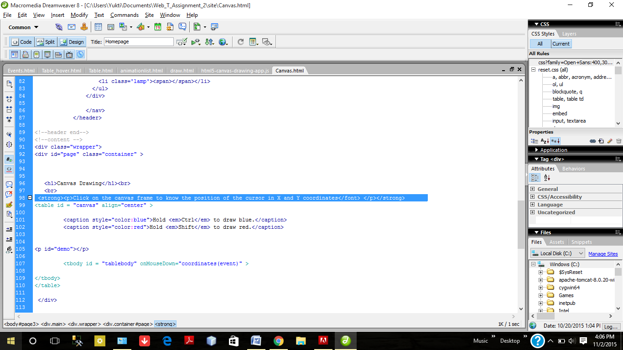

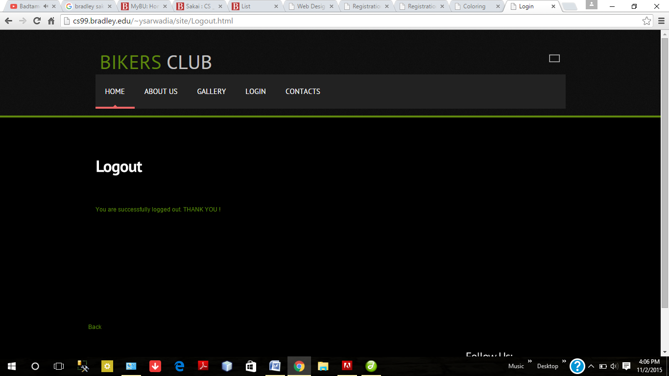

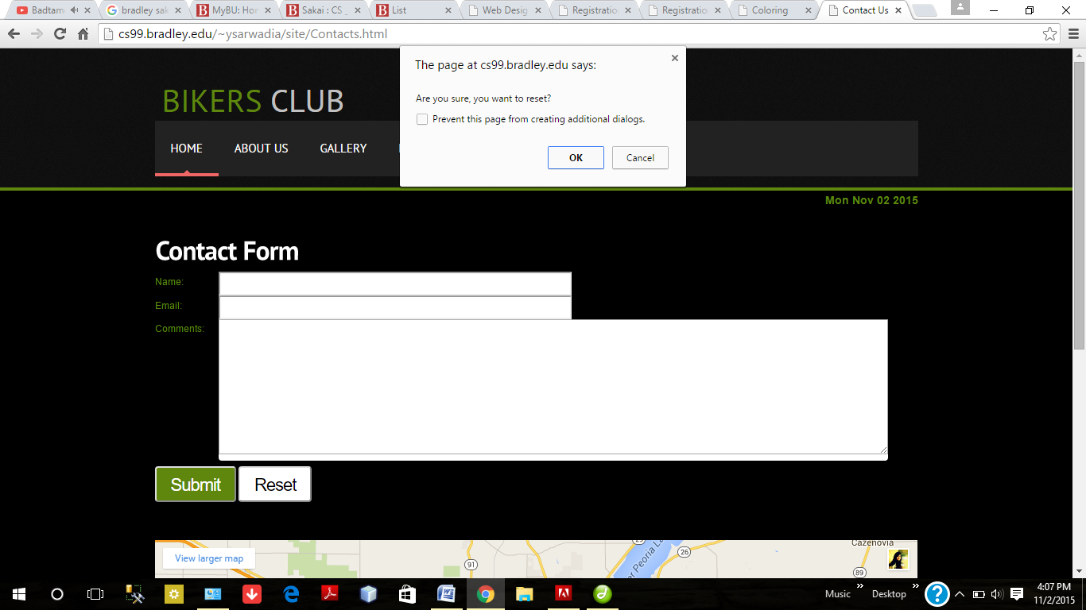

When we press reset, JavaScript validation will pop out.

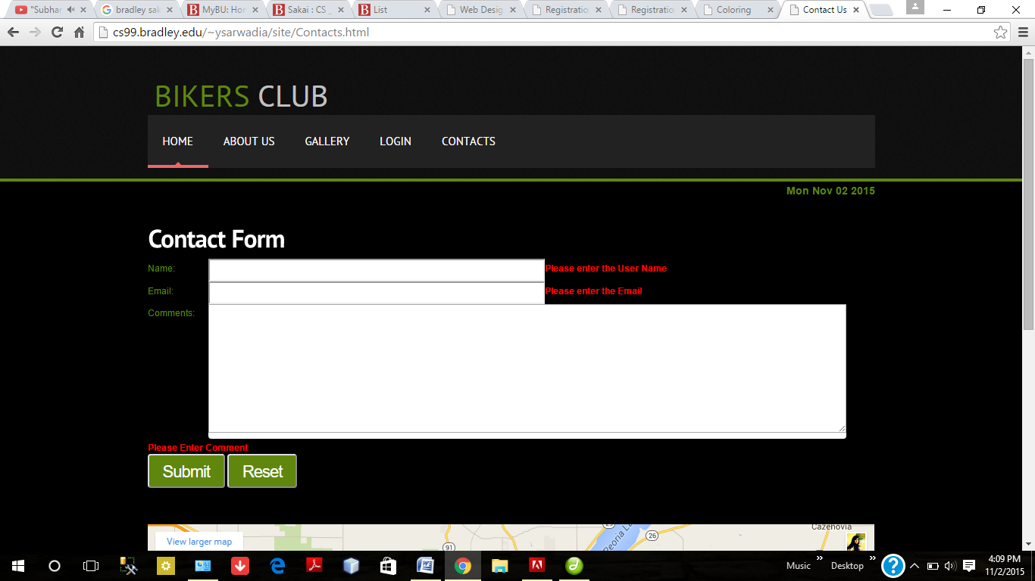

When we press submit for an empty form the inline alerts will appear.

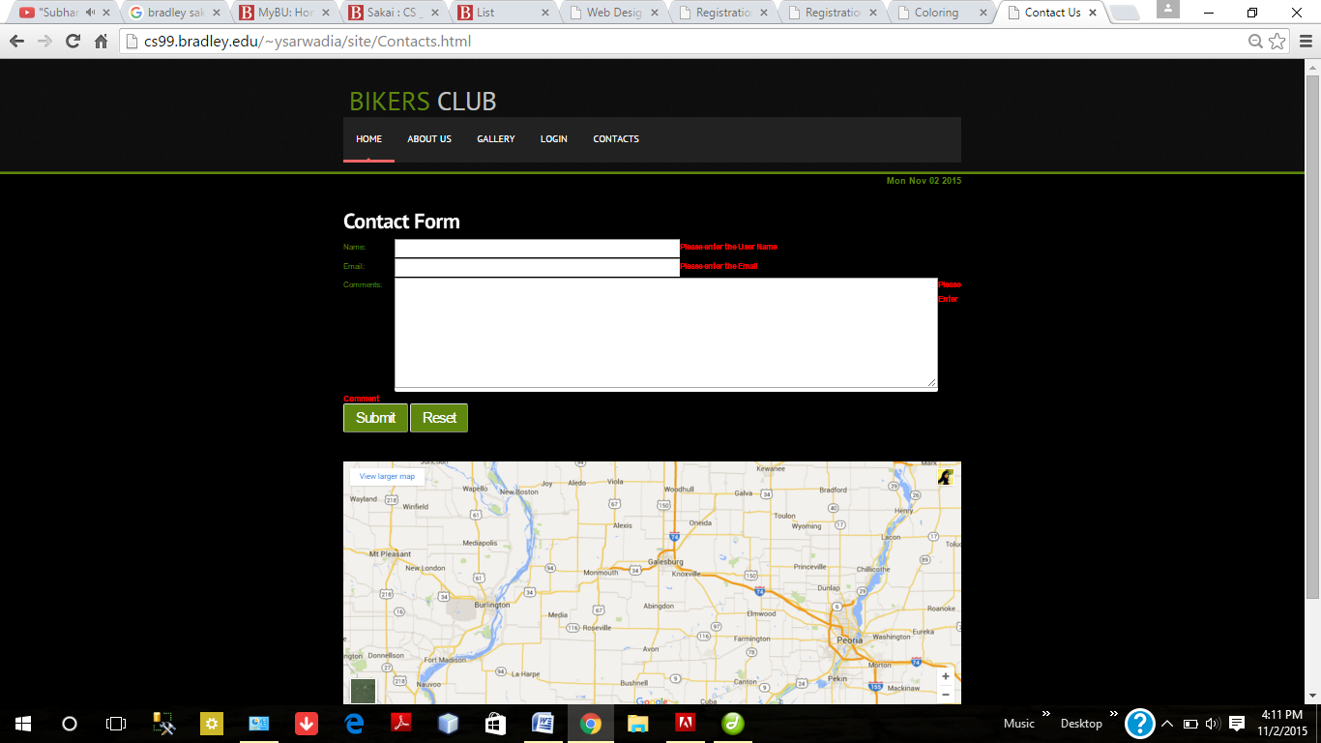

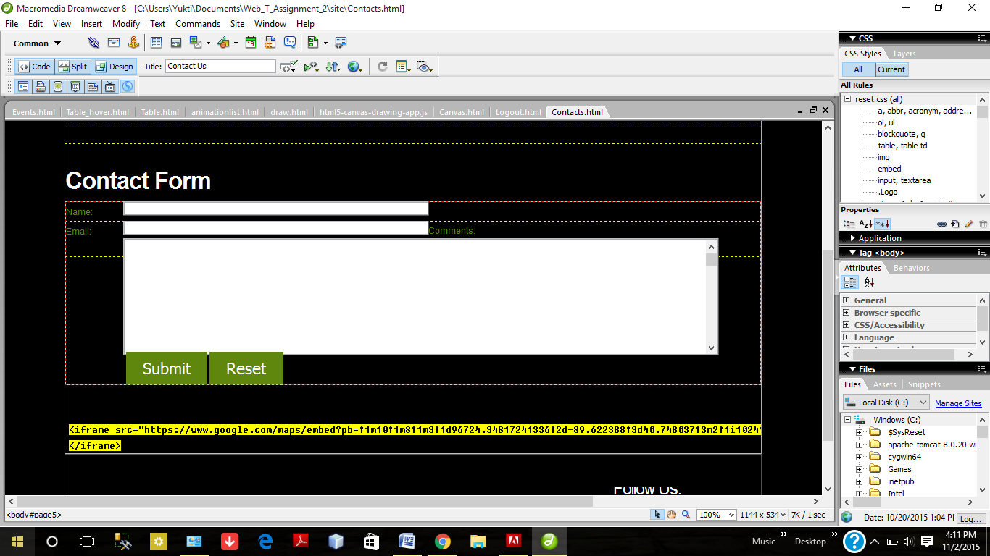

Date Object Using JavaScript

Use of <iFrame> to embed Google Maps

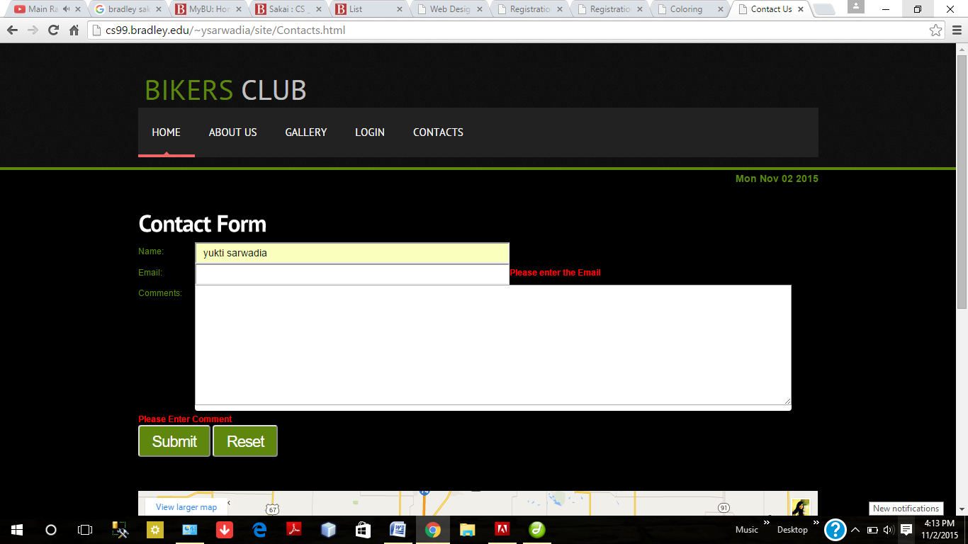

All fields are required

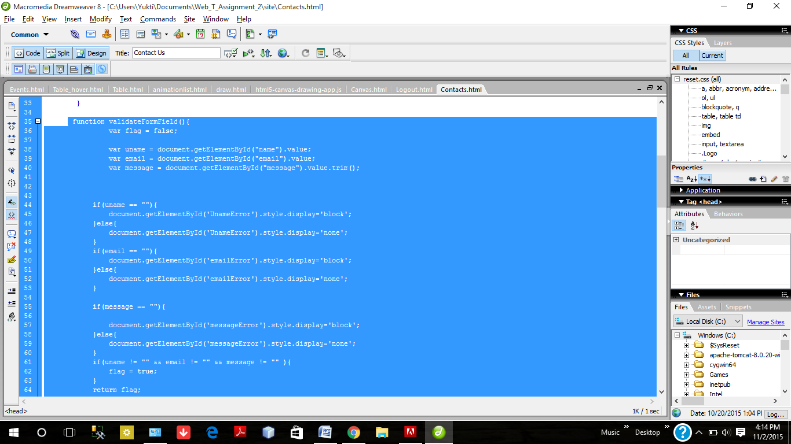

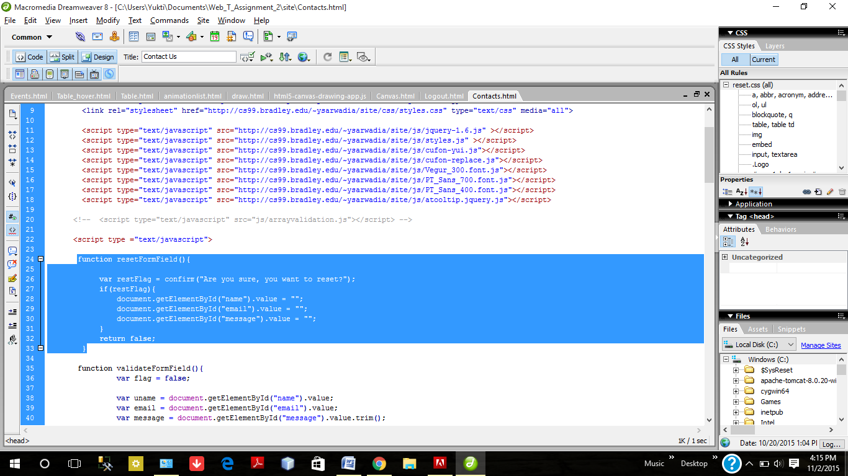

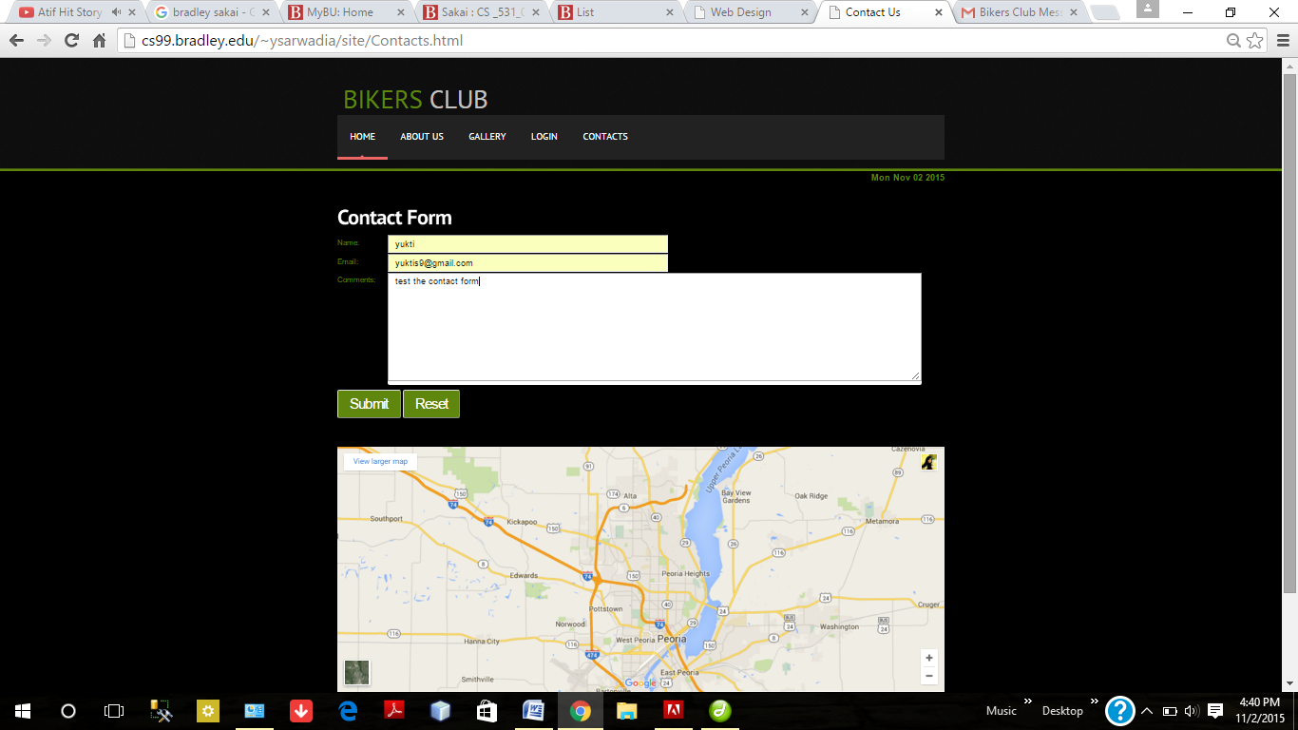

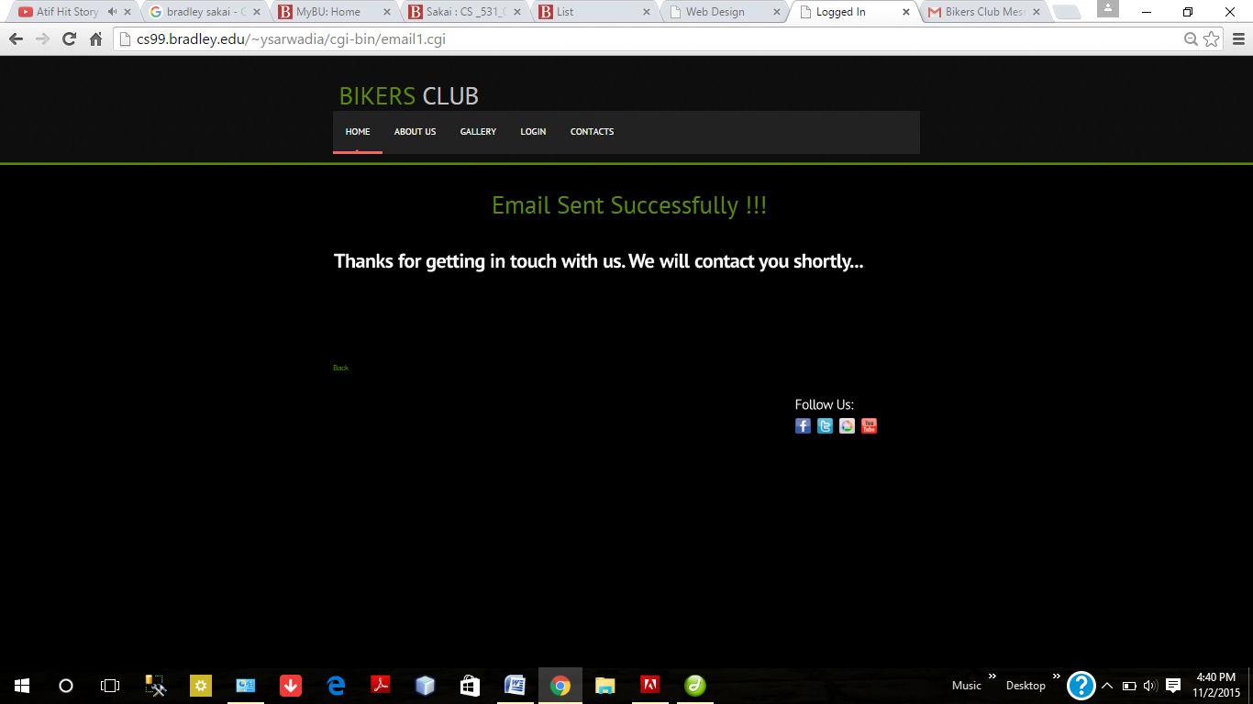

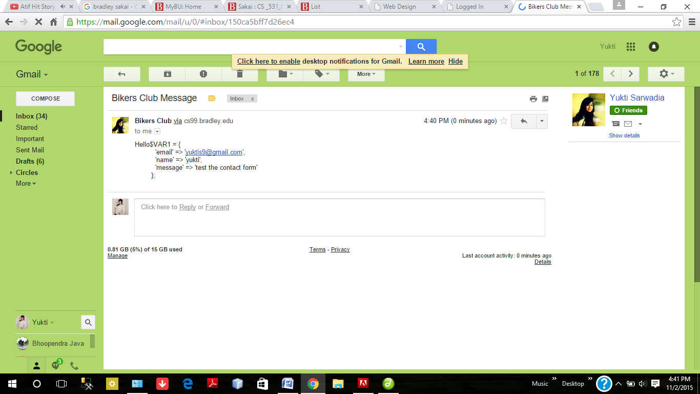

1. **SignUp Page- Combination of JavaScript and HTML5 validations**

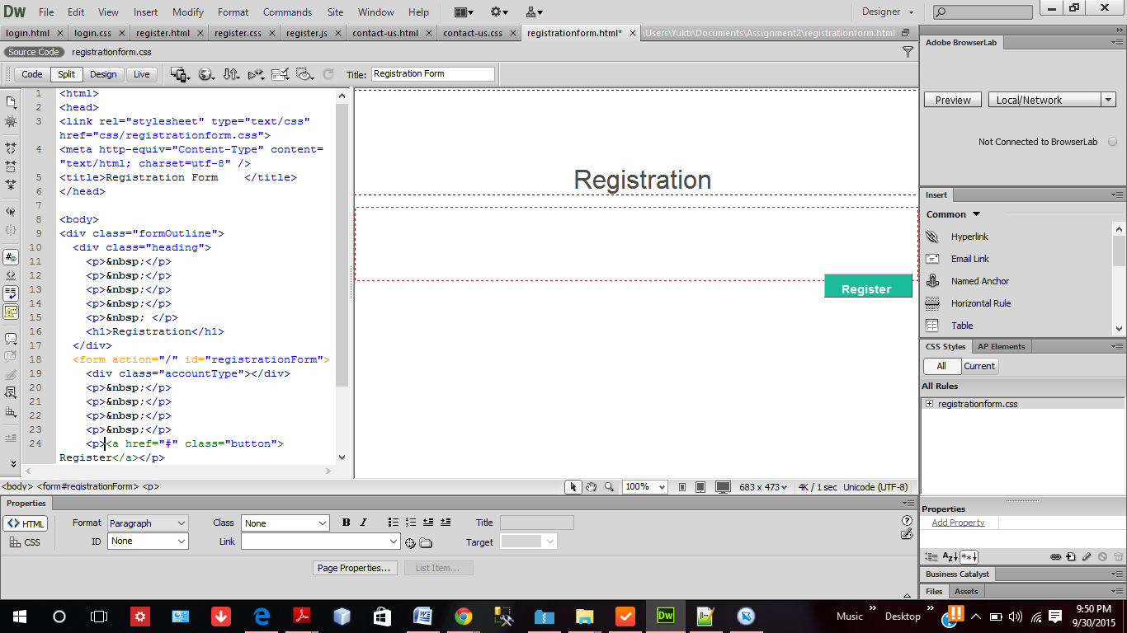

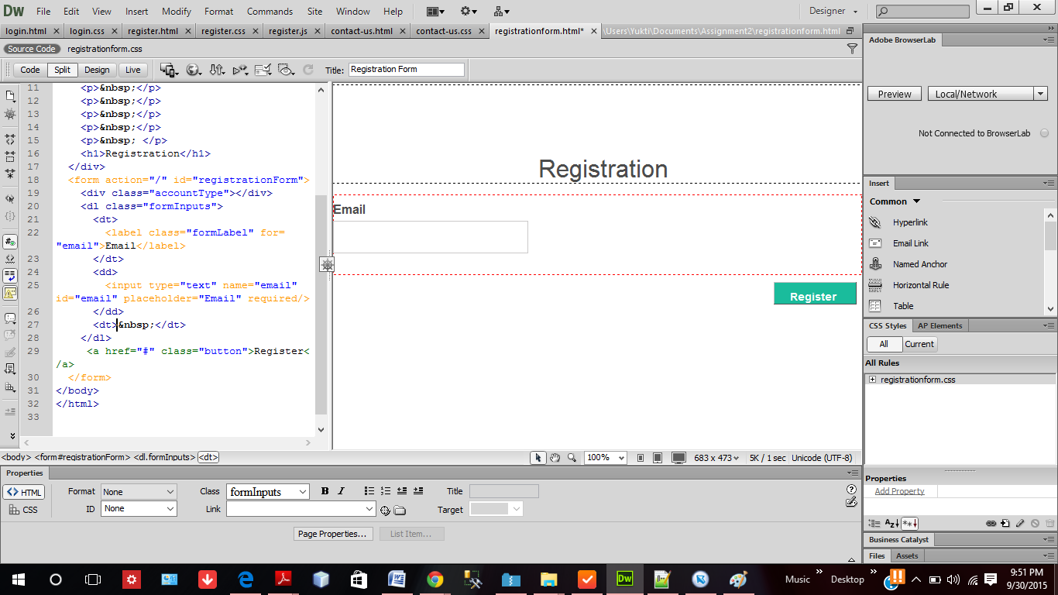

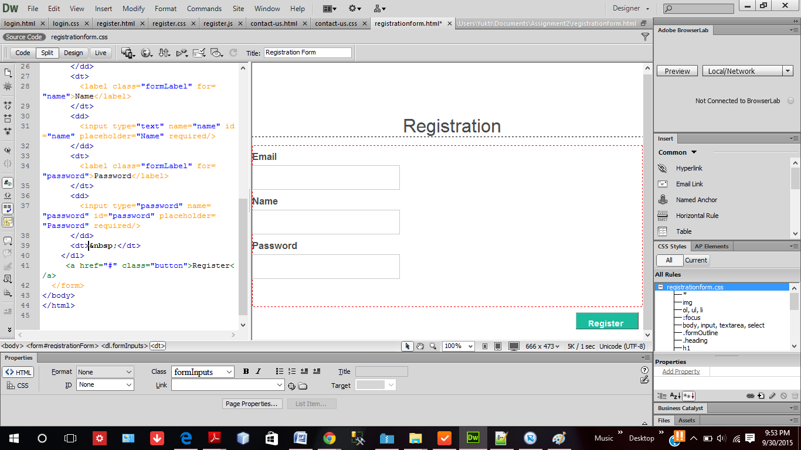

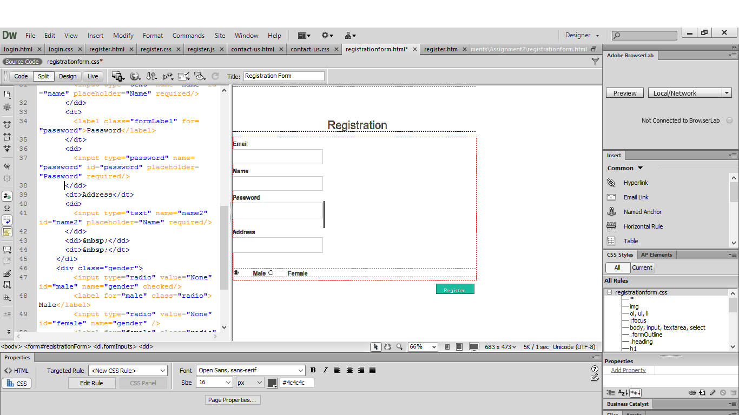

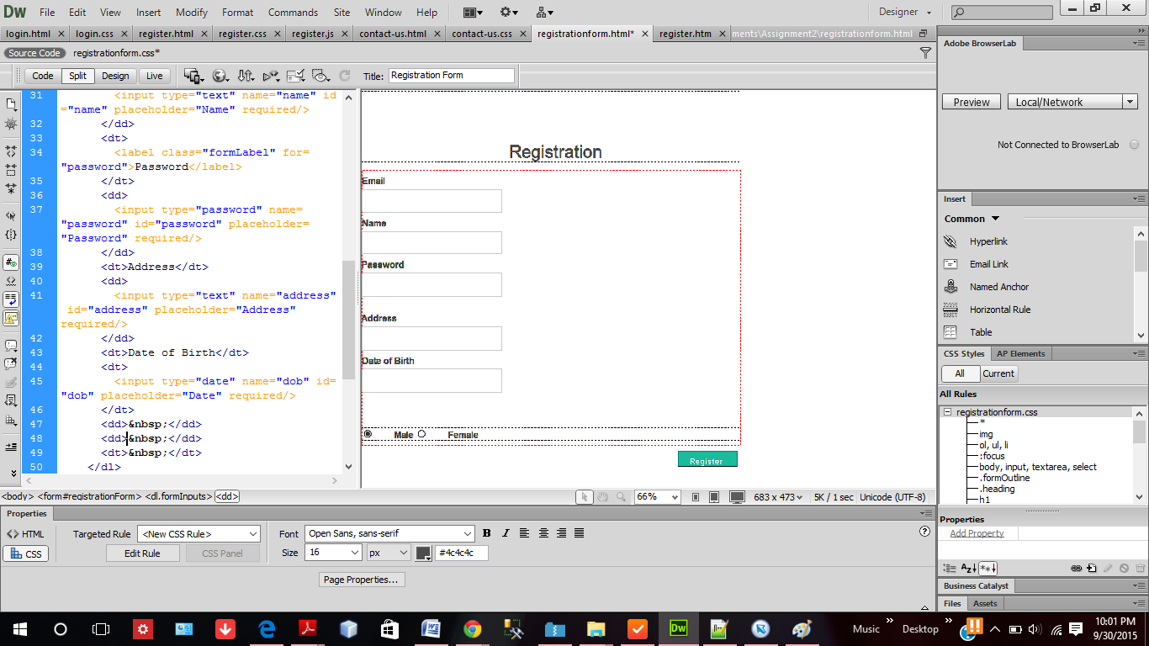

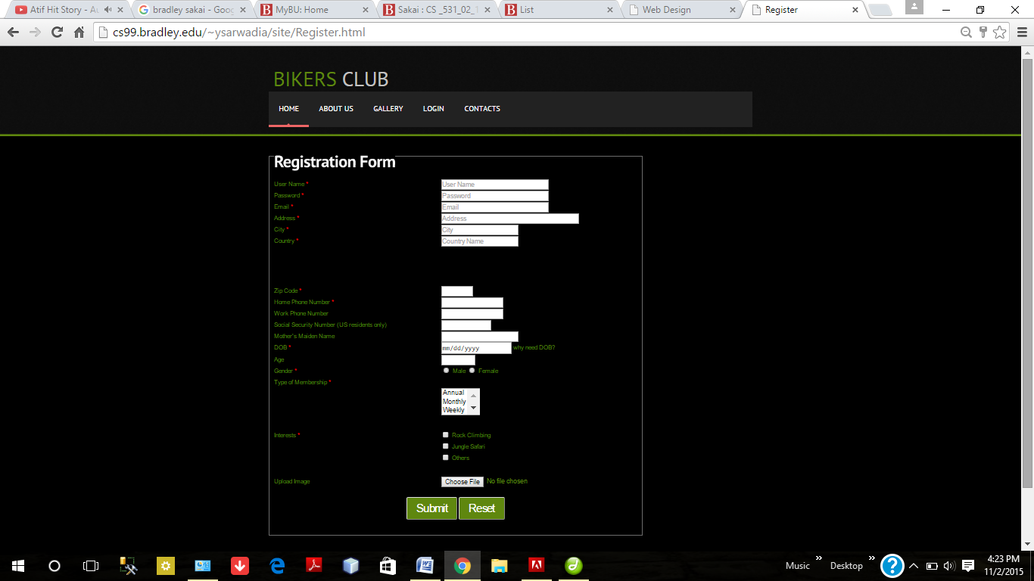

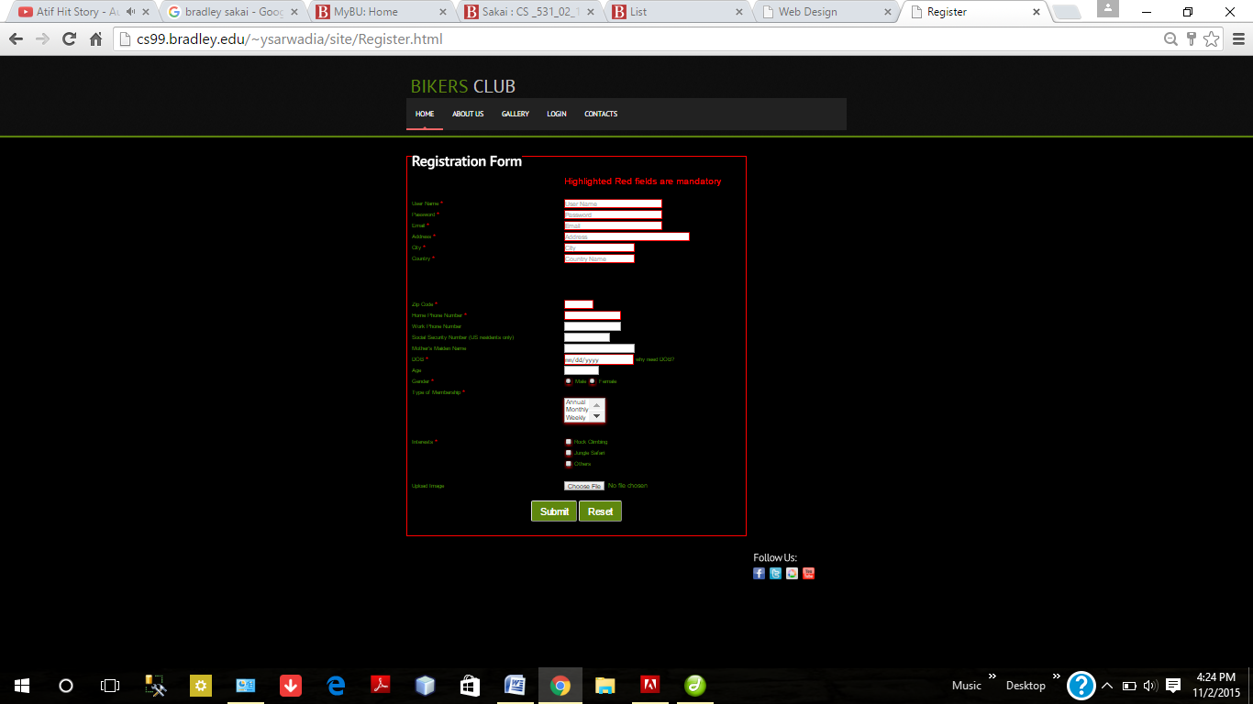

If we try to submit a empty form than because of JavaScript validation the <Fieldset> color will turn to RED and a message will be prompted to the user. All the mandatory field becomes red and non mandatory field remains as it is.

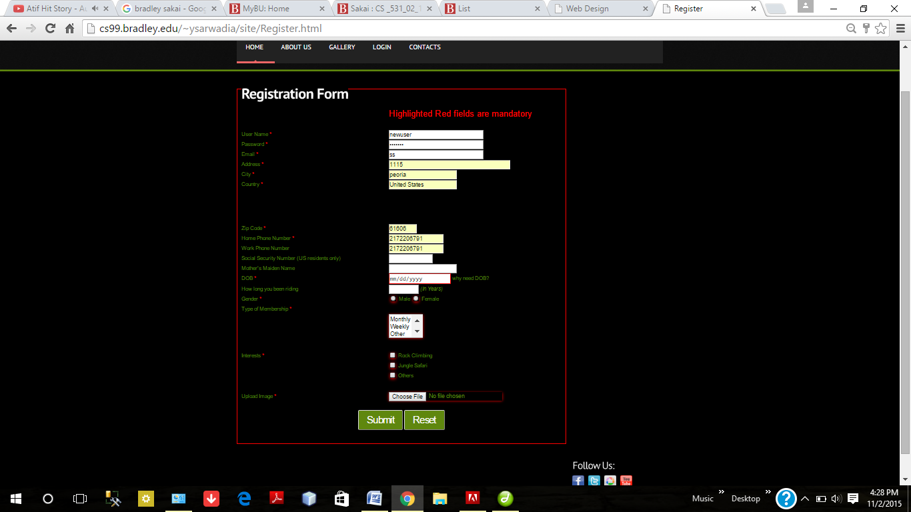

Incomplete information is not allowed.

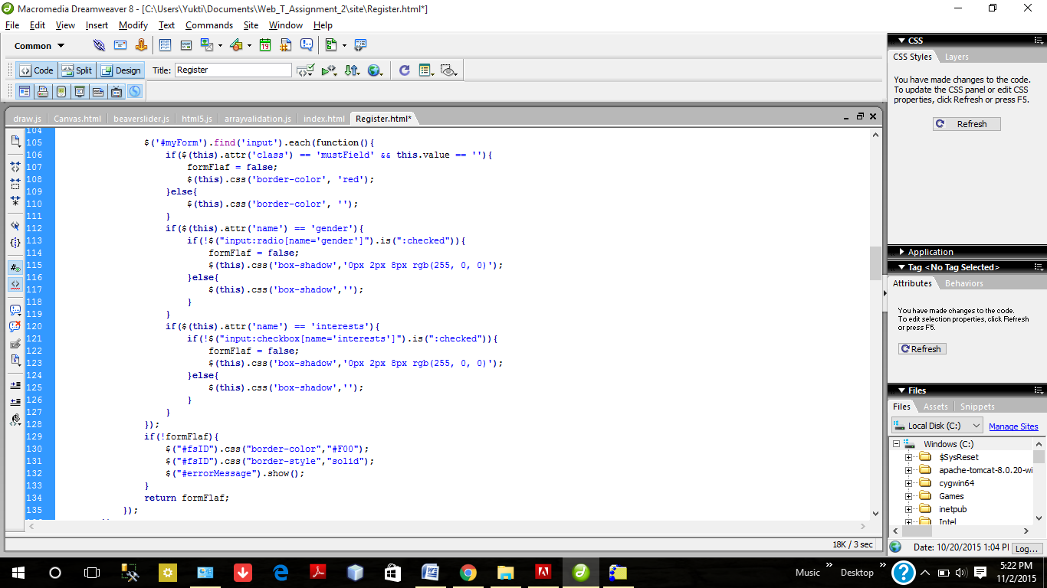

jQuery code will go to the all input type elements in the form and will check if the input type has class name mandatory and it is empty then it will add the color red to that input type by css and will make the formFlag value false. formFlag value will be set true only when there is no error in the form mandatory fields.

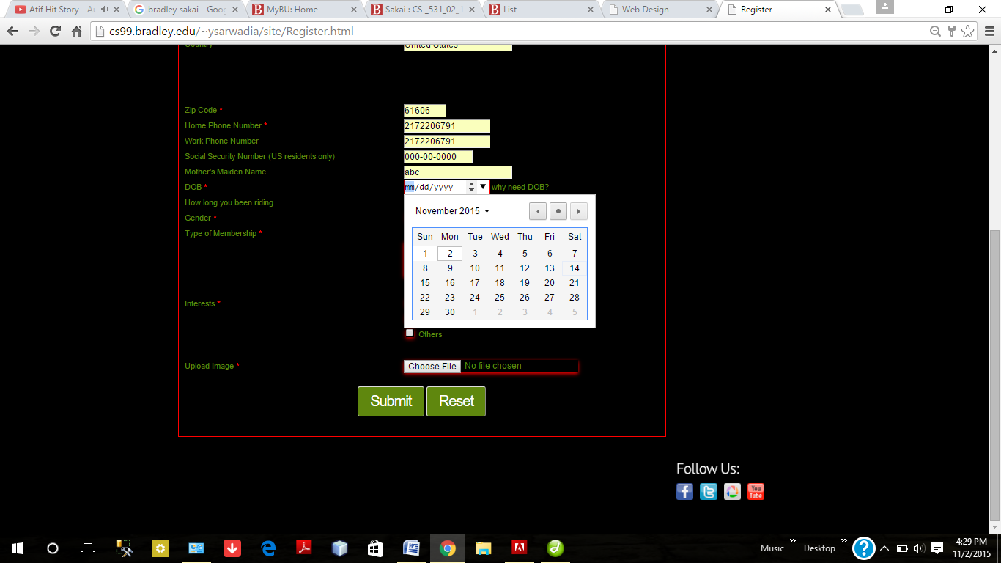

It will not accept the future dates because of JavaScript validation. We set the current date to the max field of the input type date

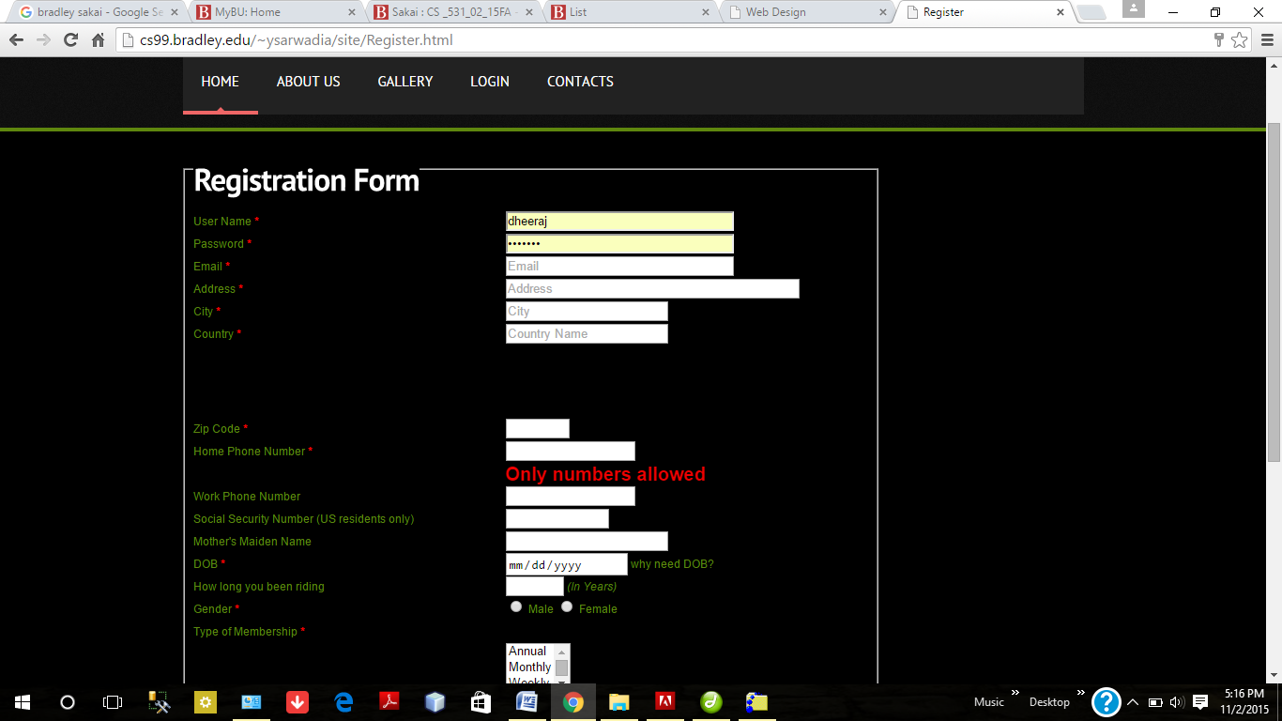

Javascript KeyPress validation on phone no filled. It will not even allowe user to enter any character. User will be allowed to enter numbers only.

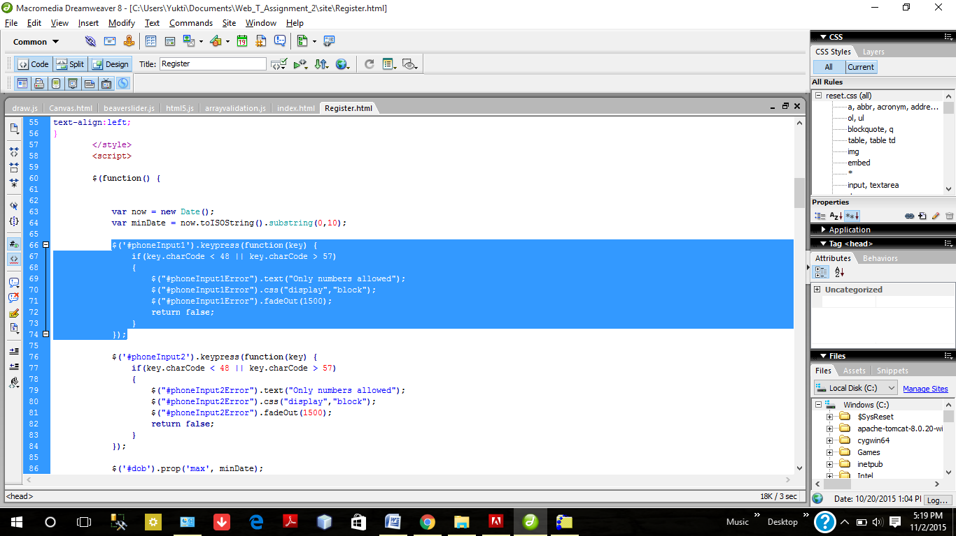

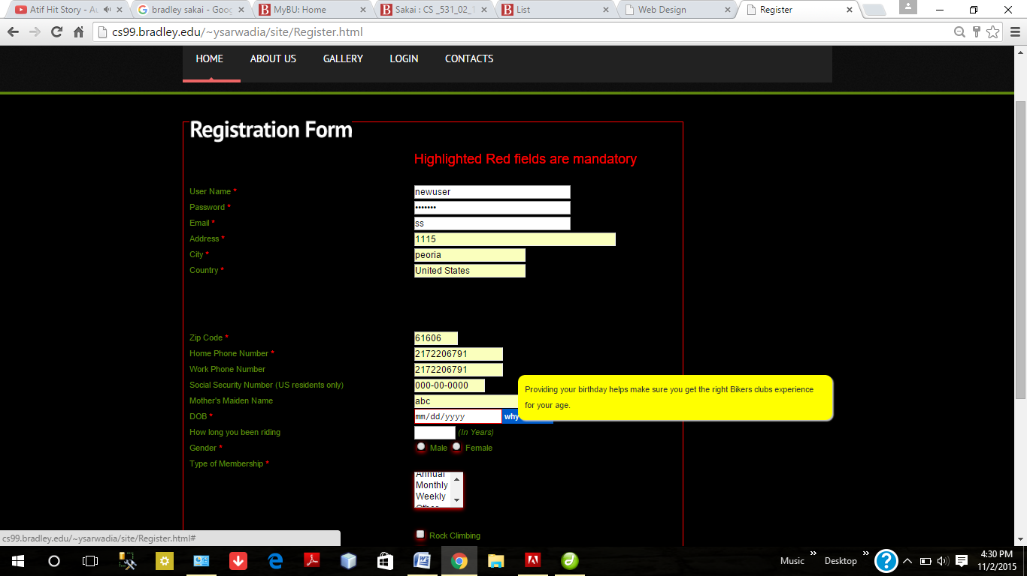

Mouse Hover Event used

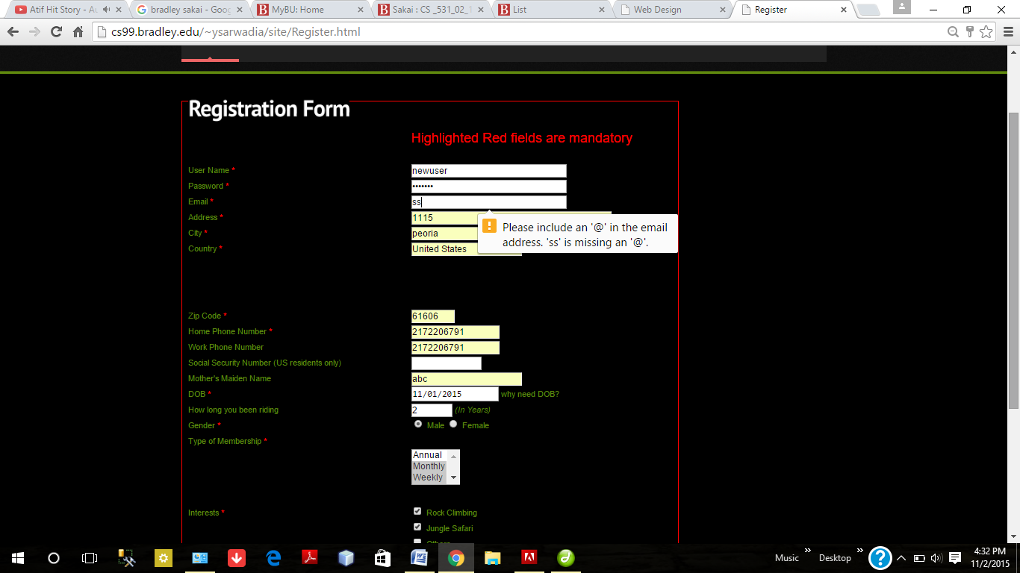

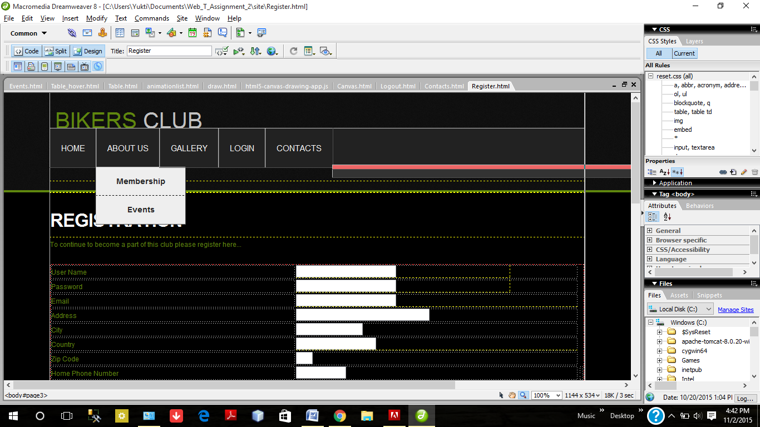

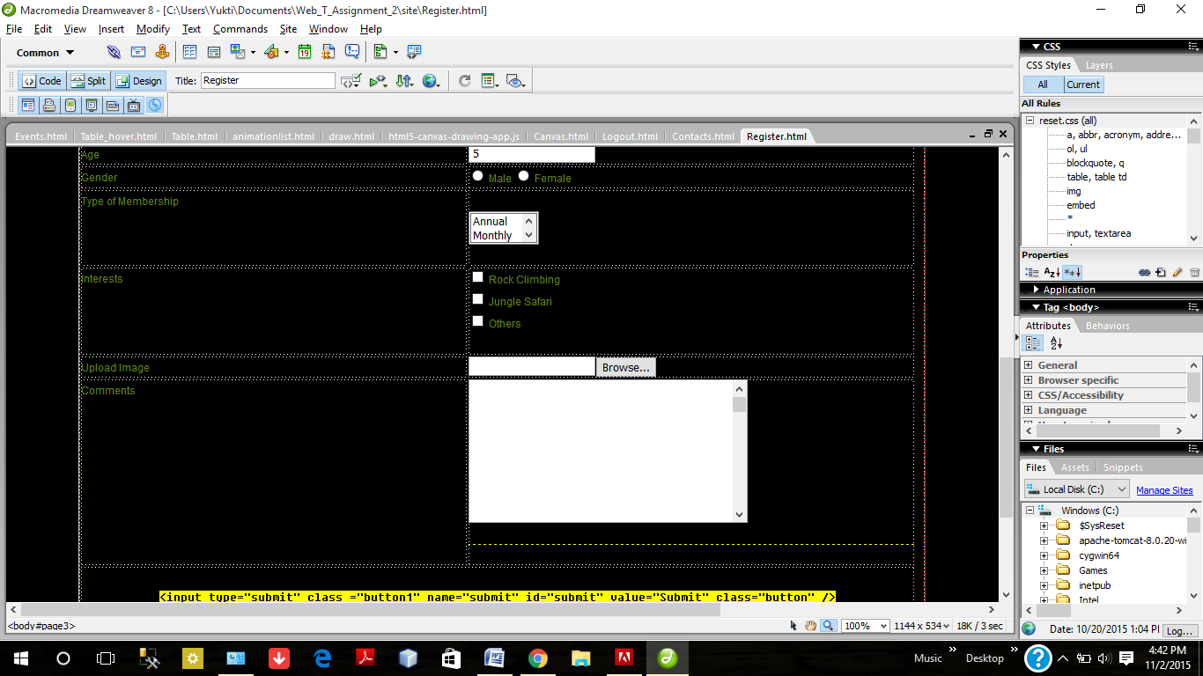

1. **HTML5 Elements used:**

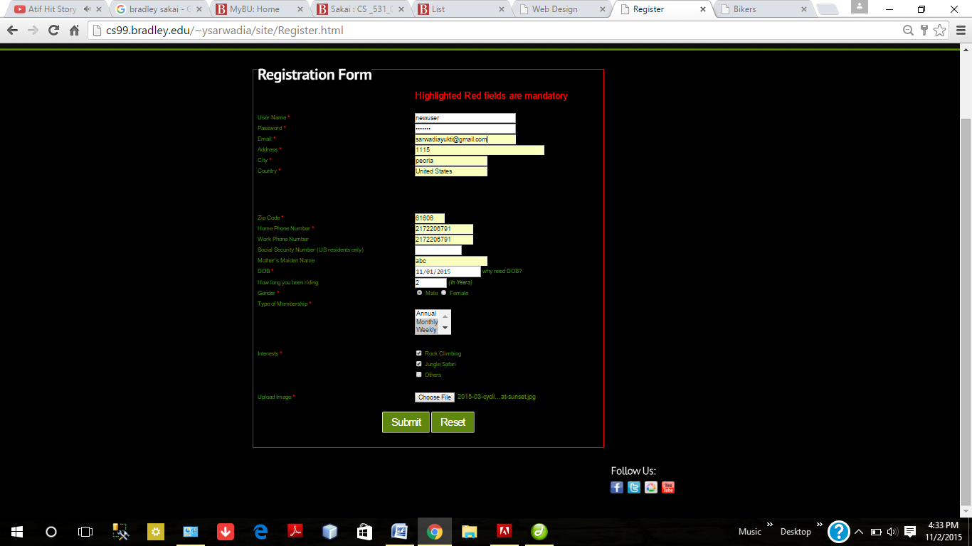

HTML5 : Nav

HTML5 : Number

HTML5 : Date

HTML5 : <input type = tel>

HTML5 : DataList

HTML5 : Email

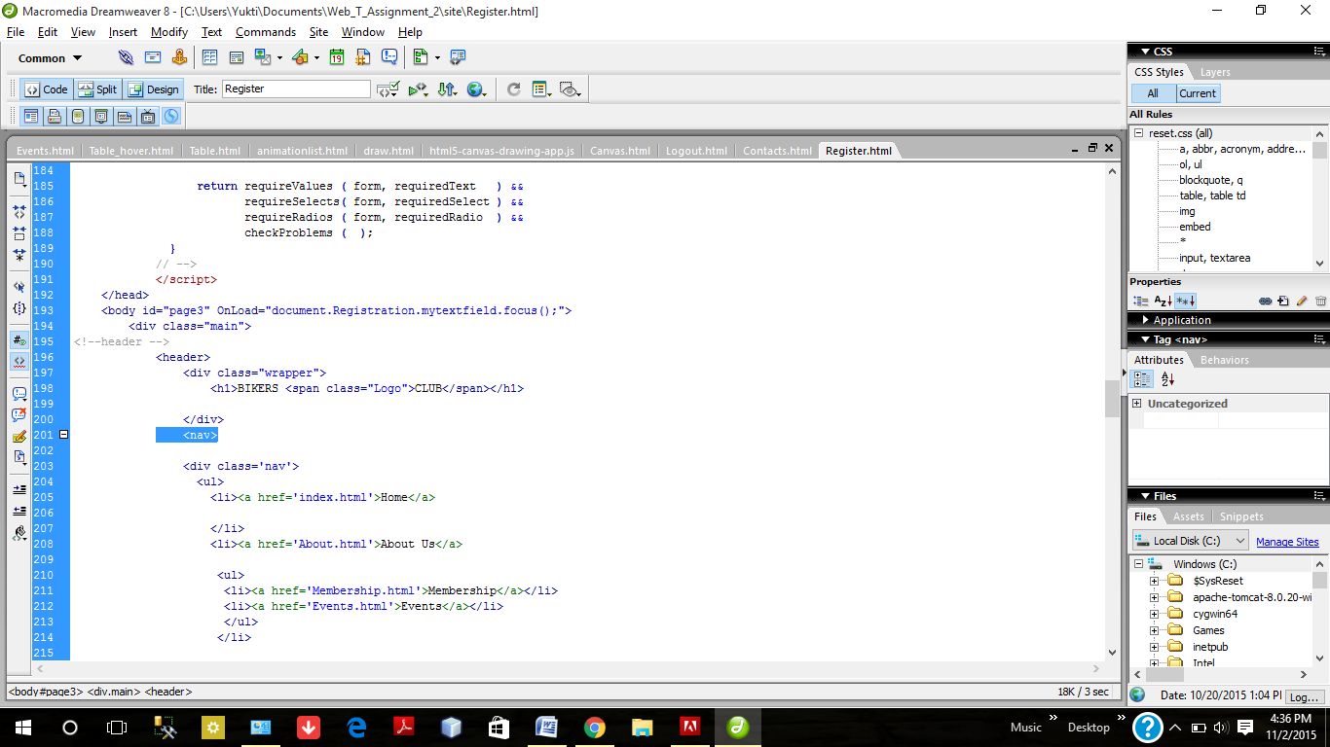

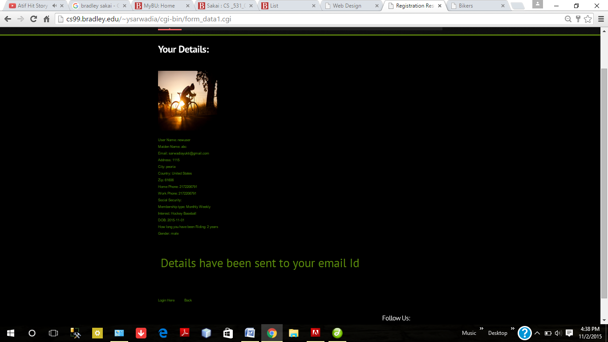

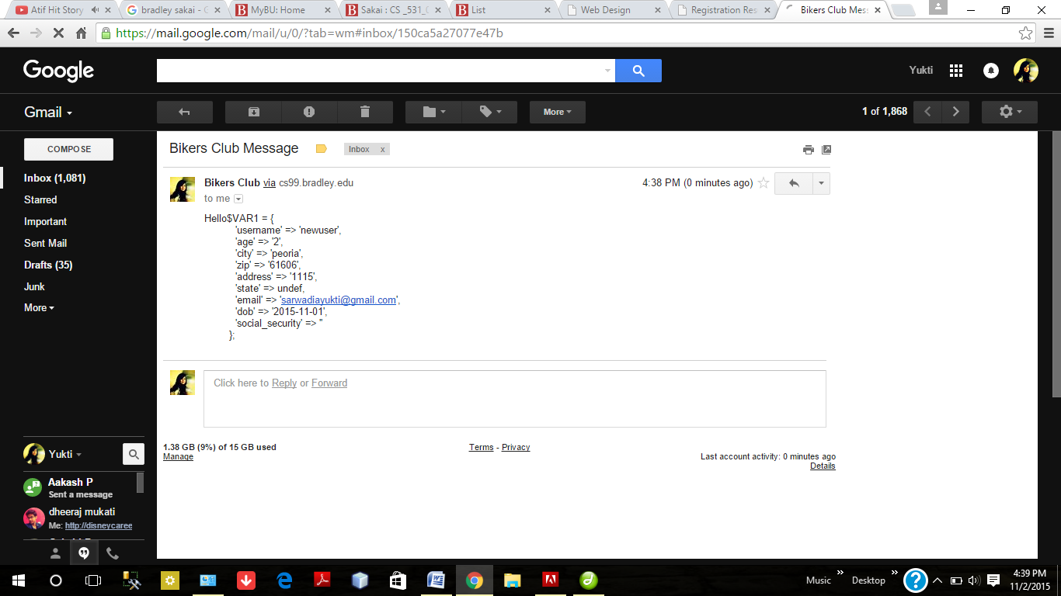

**6. Use of Control Statements**

